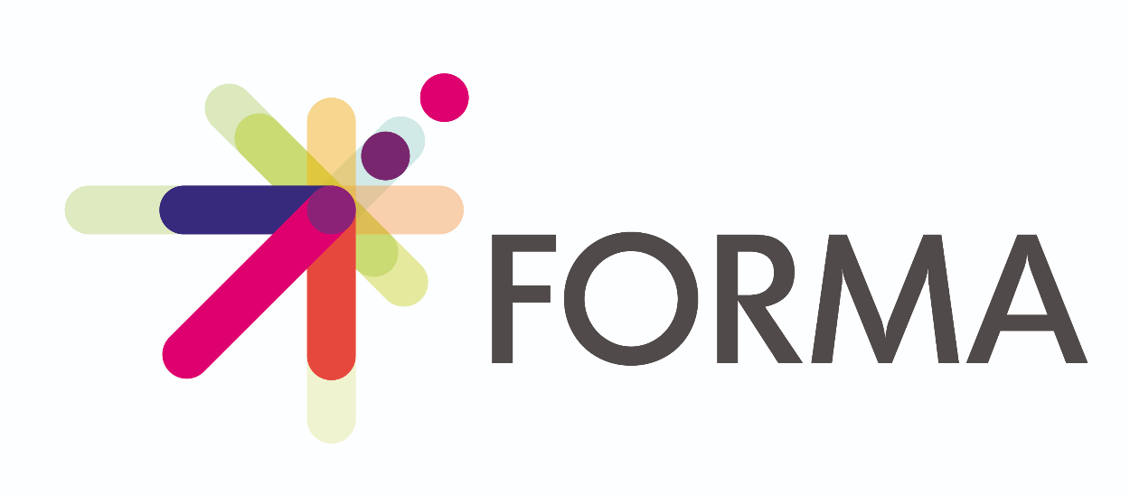
Over the last 12 months I have been involved in the design of “FormA”, the new ETF (European Training Foundation) formative assessment toolkit. Refined and finalised through the collaborative effort of international experts during a validation workshop held online on February 2nd. FormA embodies the collective wisdom and forward-thinking of seasoned educators from around the globe, inspired and guided by the concept of assessment AS learning.
The workshop was energising and engaging, where a range of feedback and creative suggestions were collated and implemented to polish the toolkit ready for launch. Slogans were developed, our favourite of which was, "Assess to Progress." This motto encapsulates the essence of FormA - a tool designed not merely to evaluate, but to empower and advance the learning process. The toolkit is built on the premise that effective assessment is the cornerstone of learning, providing both educators and learners with the insights needed to tailor educational approaches and achieve personal and academic growth. We have been inspired by the idea of assessment as learning through which learners can further practise wide-ranging competence such as, for example, critical thinking, communication, creativity and collaboration, to design and evaluate diverse assessments.
FormA stands out for its comprehensive approach to formative assessment. It offers a suite of tools and strategies aimed at enhancing the teaching and learning experience in creative and personalised ways. FormA introduces methods that go beyond traditional testing, encouraging interactive and engaging ways to capture, articulate and measure learning progress. This includes peer assessments, self-evaluations, and project-based learning assessments.
Recognising the diversity in educational settings and learner needs, FormA provides customisable tools that can be adapted to various subjects, learning environments, and age groups. This flexibility ensures that educators can implement the most effective strategies for their unique classroom dynamics. By involving learners in the assessment process, FormA promotes ownership of learning and motivation. It empowers learners to reflect on their progress, set personal goals, and engage actively in their educational journey.
FormA is more than provision of tools, as educators are encouraged to share experiences, strategies, and success stories, fostering a collaborative environment that enriches the educational ecosystem. Its launch is a testament to the power of collaboration and innovation in driving educational progress. As educators and learners worldwide embrace "Assess to Progress," the potential for transformative change in teaching and learning is realised.
FormA is more than just a toolkit; it's growth towards a more inclusive, responsive, and effective educational system. Its adoption promises to empower educators to harness the full potential of formative assessment, paving the way for a future where every learner can thrive and excel. With FormA, the educational community takes a significant step forward in realising the vision of a world where assessment is not an endpoint but a gateway to endless possibilities for growth and achievement.

