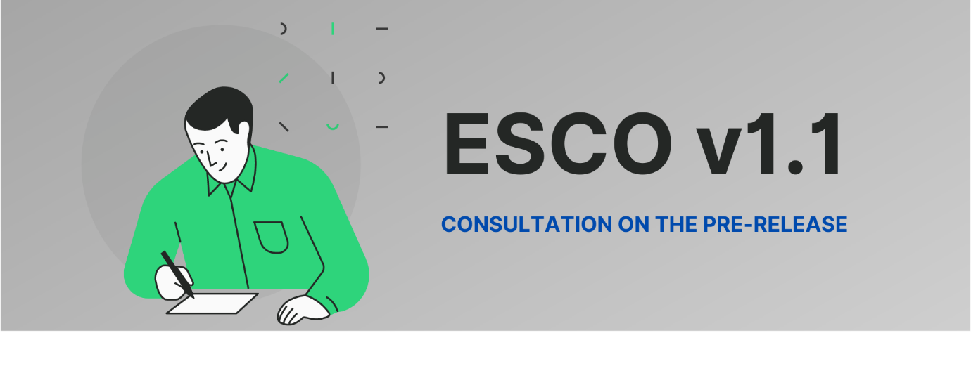Starting on 15 December 2020, the Commission is consulting on a pre-release draft of the ESCO next major version (v1.1). ESCO v1.1 will be published at the end of 2021, following a series of consultations with ESCO stakeholders including EU Member States.
The pre-release version includes a content update with occupations, skills and knowledge concepts that are not part of the current ESCO as well as a number of changes to existing occupations resulting from the content update.
The number of concepts subject to this consultation is summarised in the chart below.
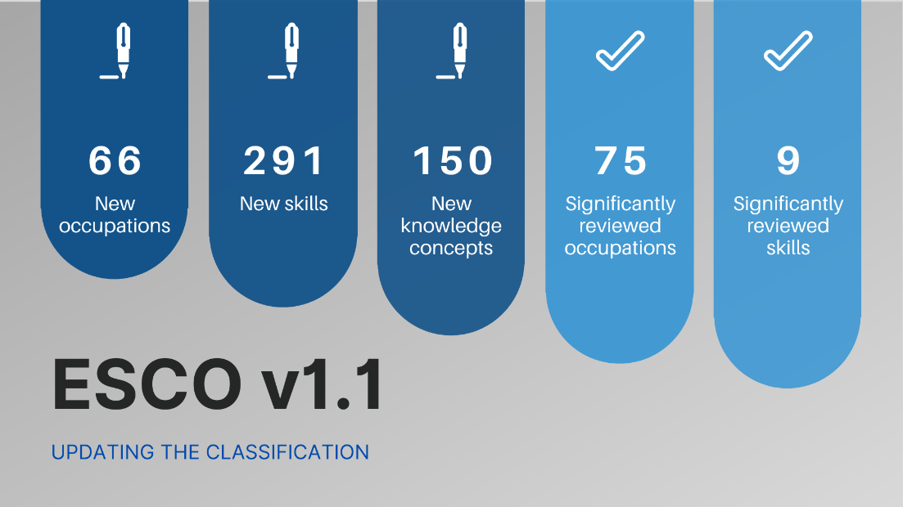
In this context, the Commission invites external feedback and comments on the proposed new terms and on the modifications to existing terms by Friday 15 January 2021.
To guide through this pre-release, an excel file (ESCO v1.1 content overview for consultation) (see Appendix for further instructions) lists all the concepts which have been created (under the tab “New content”) or modified (under the tab “Existing content”). This excel file is available to download in the Documents section (go to: Home > About ESCO > Documents). The file also includes a column to provide comments and a list of fields for filtering the feedback received according to the input type.
The infographic below provides guidance to easily access, analyse and comment ESCO v.1.1.

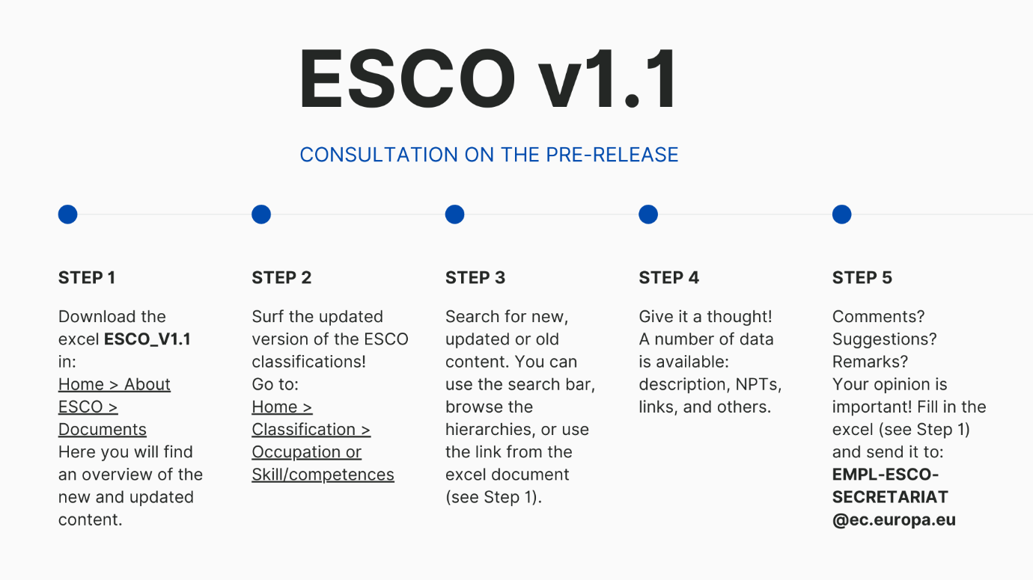
For your feedback and comments, please use the column available in the excel file and send the file back to EMPL-ESCO-SECRETARIAT@ec.europa.eu.

Appendix: Instructions for the Excel file
This file contains all the concepts that have been created or modified following the exercise of the content update. It contains a tab for the new concepts, one for the pre-existing ones, and the last provides some numbers about the exercise. The purpose of this file is to provide information about the updated content, and to be a tool for you to provide your feedback and comments.
The first tab contains the new concepts, and is composed as follows:
- Label: it indicates whether a concept is green, digital, or other. It is possible to filter for these categories by clicking on the arrow in the cell B1 and selecting the preferred filter.
- Concept title: It is the name of the concept or the preferred term in ESCO terms. It is the term that best represents the concept in a chosen language, English in this case.
- URL: Here you find the link to the concept in the pre-release environment, were you will see how the concept will look in the ESCO portal.
- Type: Here it’s indicated whether the concept is an occupation, a skill, or a knowledge. It is also possible to filter for it as in the Label column.
- Issues: If you have concerns about a concept, you can indicate it in this column, there are some pre-selected values among which you can choose the most appropriate one.
- Proposed solutions: If you flagged a problem, please use this column to explain how you would fix it.
The second tab contains the pre-existing concepts which have been modified, it has the same structure of the first one without the filter for the Label.
The third tab presents the numbers of the content update, how many concept have been created for each type and how many have been modified.

