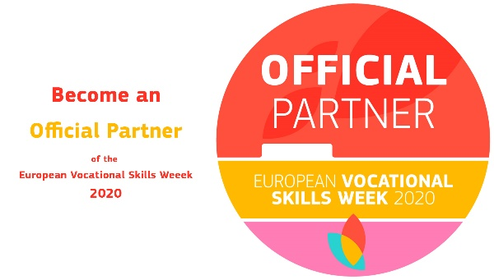
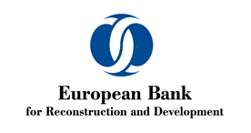
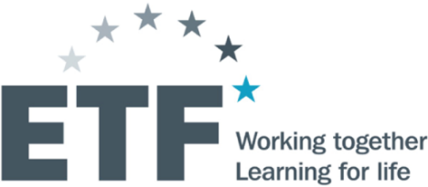

the role of the private sector in the youth SKILLS ECOSYSTEM

How to promote Smart, Sustainable and Inclusive Skills

SOUTH EASTERN EUROPE and Turkey

9th November 2020 (10.30 - 13.00 CET)
Online Event on ZOOM Platform

Background
Even in the best of times, young people face a tough situation in the labour market. At the global level, young people aged 15-24 are more likely to be unemployed compared with adults aged 25 and above. The current COVID-19 crisis is additionally aggravating their position.
Public and private sector have boosted their efforts to respond to these ever-growing challenges. Whilst private sector organisations define their future of work strategies, at the same time they have increased their efforts to invest into designing, delivering and financing innovative approaches to education and skills development, targeting underserved groups, to support greater transition into employment and reducing the likelihood of future levels of high unemployment. In order to truly ensure there is a place for all in the future of work, public, private, academic and non-profit organisations, communities are working more closely and in partnership to collaboratively define the skills needed for young people.
Most often, such initiatives revolve around up-skilling and re-skilling. In order to achieve more sustainable and progressive impact, we explore if more be done, not to only ensure youth have an equal footing, or are less disadvantaged, but to sway the advantage to their side making them the most competitive and productive workers.
Within the context of the European Vocational Skills Week, the European Training Foundation (ETF) and European Bank for Reconstruction and Development (EBRD) would like to bring attention to issues considered to critically impact the skills of youth and their economic inclusion, but also the productivity and growth of their economies.
Both institutions associate policy engagements and financial support to achieve the greatest impact by prioritizing equitable access to jobs and skills for young people. Both institutions work jointly not only to understand the impact of the future of work on diversity and inclusion, but also at identifying, analysing and sharing good practices for innovative approaches in adopting inclusive skills development strategies and practices with focus on skills for economic and social inclusion of young people.
Objective
On this occasion, we would like to focus attention on the role of the private sector in the process of skills development. In order to do this, we will explore the role of enterprises in identifying skills needs, developing occupational and qualification standards or curricula and similar in providing input to policy design, as well as their role in direct training provision - be it through informal skills development, or through collaboration with adult VET centres or VET high schools. We shall also explore the more forward looking, cutting edge, aspect of private sector engagement by examining investments and partnerships in R&D across SEET.
This will also be an opportunity gain insight into the findings of the new ETF study “Unlocking Youth Potential in South Eastern Europe and Turkey: Skills development for labour market and social inclusion" and to understand EBRD’s innovative private sector youth inclusion.
Key questions
What are the current examples and best practices of private sector engagement in youth skills development and labour market inclusion?
What are the current relations and models of cooperation between the public and private sector when it comes to youth skills development and how can these evolve?
What are the roles of the academia and the private sector and how do they interplay in R&D and how is this knowledge translated into the skills of the current and future workforce?
Participants include education, labour, social affairs and youth ministries and agencies of the SEET countries, private sector representatives, non-governmental organisations including youth organisations, research community, EU Delegations or offices in SEET, European Commission, EBRD, regional and other international organisations.
Agenda (draft)

Facilitator: Lida Kita, Specialist in VET and Social Inclusion - Country Coordinator Serbia, Turkey and Israel
10:30 – 11:00 – Welcome session
ETF and EBRD approaches to private sector involvement in skills development for economic, social and labour market inclusion in SEET
Anastasia Fetsi, Head of Operations Department, ETF
Barbara Rambousek, Director, Gender and Economic Inclusion Team, EBRD
Barbara Banki Gardinal, Head of Unit, Directorate-General for Neighbourhood and Enlargement Negotiations, European Commission

11.00 – 11.55 Session one: Cooperation and complementarity - public and private sector in youth skills ecosystem
Moderated by Biljana Radonjic Ker-Lindsay, Associate Director, EBRD
- Dajna Sorensen, Deputy Minister, Ministry of Finance and Economy, Albania
- Ahmet Koral, Senior Education and Training Specialist, Brisa Academy, Turkey
- Slobodan Anic, Country Manager, AMETEK, Serbia
- Mladen Perazic, Head of Sector for Education, Chamber of Economy, Montenegro
- Gligor Cvetanov, Managing Director, Makprogres – Vincina Academy, North Macedonia

11.55 - 12.50 Session two: Skills, innovation and technology development
Moderated by George Zisimos, Senior Specialist in EU Education and Training Policies, ETF
- Zeynep Dereli, Founder of Tink, Technology and Human Colleges, Turkey
- Jan Wilker, Goethe Institute Brussels
- Laoura Ntziourou, Mandate Management officer, Strategy & Business, European Investment Fund
- Mentor Rexhepi, VentureUP - University of Prishtina Entrepreneurship & Innovation Center, Kosovo
- Mustafa Hrasnica, Professor at Faculty of Civil Engineering Sarajevo, Team Leader of All4R&D, accelerator of research, innovation, knowledge and technology transfer, Bosnia and Herzegovina

12:50 – 13:00 Concluding session

Biljana Radonjic Ker-Lindsay, Associate Director, EBRD
Anastasia Fetsi, Head of Operations Department, ETF

Concluding remarks and key messages

