


ET2020 Working Group
Digital Skills and Competences

Data FOR Education and Data IN Education
Tallinn, 4-5 October 2017

DRAFT AGENDA

Day 1

9:30 | Registration
10:00 | Introduction and welcome
10:30 | Data for Education and data in education ie open data and assessment
11:15 | Morning Break
11:30 | E-assessment in General and Vocational Education – concept, value added, lessons learnt
 | E-level tests in primary education (experience for 3 years)
 | E-assessment of key competences (including digital competence) in formal education
12:30 | Lunch
13:30  Workshops | Workshop 1 - Tools to measure adults’ skills. Estonia (PIAAC online), France (Pix)?....?
13:30  Workshops | Workshop 2 - Assessment of Transversal Skills for Students, Erasmus + project. Initial conclusions (Premier!) (Cypros)
13:30  Workshops | Workshop 3 | Digital skills and labour market - improving digital skills of employees (Shared Concept for a Digital Skills Strategy). Experience from Estonia and…..?????
13:30  Workshops | Workshop 4 | Innovative programmes (ongoing or concluded) – programmes aimed at addressing 21st centry skills – entrepreneurship, mathematical skills (analytical skills) …… Estonia, ……..???
15:00 | Afternoon break
15.00  Workshops | Workshop 1 – digital empowerment of schools – whole school approach and DigCompEdu
 | Workshop 2 – Assessment of teachers digital skills (Mentep? DigCompTeach? Opeka (FI)?)
 | Workshop 3 – Innovative programmes (ongoing or concluded) - e-assessment and artificial intelligence, learning analytics programm to stimulate learning – Greece?.....? ……?

Day 2

9:30 | Site visits to schools and teacher training institutions (locations TBC)
13:00 | Lunch break
14:00 | Conclusions from the site visits and key conclusions on common grounds and principals of e-assessment. Presentation of different research studies?
15:45 | Coffee
16:00 | Presentation of different research studies? ……?  Visit to e-Showroom – presentation of e-government etc solutions.
17:30 | End of day 2

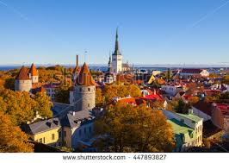
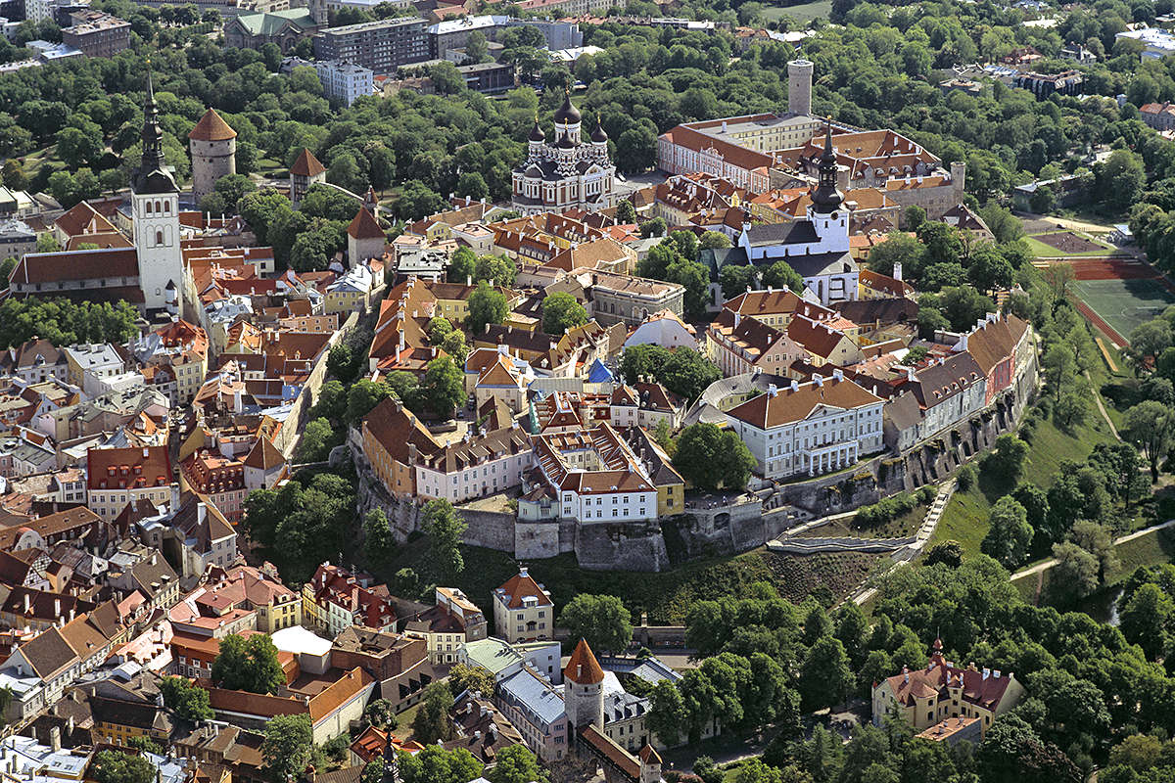
Tallinn in autumn


