Report: VET teacher placement
- Introduction
Transition from the industry era to the information era expose every sphere of society to changes and rapid adaptation so that it can at any time respond to today's challenges. The necessity of adaptation has also been recognized in the contemporary education system, which as a key requirement puts professional development of teachers. Professional development of teachers is a process that takes place in continuity and implies improving the skills and competences of teachers with an aim to improve the quality of educational work.
The education system should be organized in way to give teachers the opportunity to be prepared for the current roles in the society they are entrusted with, not allowing them to choose whether the teacher wants or does not want to. The quality of the teacher's work is reflected in continuous professional development that gives the teacher benefits in terms of expanding and deepening knowledge, developing skills and competencies that are relevant to the success of the curricular and extracurricular activities of the students as well as establishing quality and successful co-operation with colleagues and school management, relationships with parents and the local community.
Continuous professional development of teachers implies attendance not only of certain seminars, but also participation in conferences, workshops, networking with teachers, membership in professional associations, research and participation in training.
In the field of vocational education, where teachers of practical classes are expected to keep up to date on the labor market and innovations in their field of work, we find that it is in practice different and it is necessary to establish cooperation between schools and employers in the form of teacher training. In order that one teacher is able to transfer knowledge on students well, he must be well trained in his field and for the first time in Montenegro, in 2016, a teacher training was organized with the employer within the project "Continuous Professional Development of Teachers and instructors in the Montenegrin vocational education ". Through this pilot project, 20 teachers from 5 vocational schools have been co-operating with employers from Montenegro. The project is also continued in 2017 under the title "VET teacher placement". The aim of this project is to encourage stronger co-operation and exchange of knowledge between teachers in vocational schools and employers in order to support the professional development of teachers in Montenegro and improve the compatibility between the education system and the labor market. This project also contributes to the better cooperation of schools with employers, thus opening up the possibility for employers to participate in regular school classes and thus potentially providing a job for students who demonstrate knowledge and skill in performing work tasks with the employer.

- Project description
In 2017, the project consists three cycles of training, providing training for 72 teachers of Montenegrin vocational schools. During the training, in every company instructors are given to every single teacher. Instructors point them to news from their field. The duration of one training cycle, comparing with the previous project, is limited to one week. The first cycle was held from 03 to 07 April. The table below presents an overview of teachers and employers in the first cycle of training deployed by the areas they teach in practical classes.

CITY | NAME OF SCHOOL | No. | NAME OF TEACHER | FIELD | EMPLOYER
Bijelo Polje | JU Srednja elektro-ekonomska škola | 1 | Rakonjac Tatjana | electronics | Elektrodistribucija Bijelo Polje
Bijelo Polje | JU Srednja elektro-ekonomska škola | 2 | Pajović Miodrag | electronics | Elektrodistribucija Bijelo Polje
Bar | JU Srednja stručna škola | 3 | Dragica Zejak | traffic | FORMONT DOO - BAR
Bar | JU Srednja stručna škola | 4 | Milovan Gojković | mechanical engineering | AUTO KUĆA "ŠĆEKIĆ",
Herceg Novi | JU Srednja mješovita škola "Ivan Goran Kovačić" | 5 | Vavić Ljiljana | health care | Institut Dr Simo Milošević
Herceg Novi | JU Srednja mješovita škola "Ivan Goran Kovačić" | 6 | Vujičić Željko | health care | Institut Dr Simo Milošević
Pljevlja | JU Srednja stručna škola | 7 | Miljan Mitrović | hospitality | DOO TAŠA
Pljevlja | JU Srednja stručna škola | 8 | Remzo Hrković | hospitality | DOO TAŠA
Bijelo Polje | JU Srednja stručna škola | 9 | Međedović Zlatko | mechanical engineering | DOO Mikromont
Bijelo Polje | JU Srednja stručna škola | 10 | Kordić Radoje | hospitality | HD Farm DD (Beograđanka)
Podgorica | JU Elektrotehnička škola "Vaso Aligrudić" | 11 | Dragica Milentijević | telecommunications | Željeznička infrastruktura Crne Gore, Sektor: Telekomunikaciona mjerenja
Podgorica | JU Elektrotehnička škola "Vaso Aligrudić" | 12 | Persa Đaković | telecommunications | Željeznička infrastruktura Crne Gore, Sektor: Telekomunikaciona mjerenja
Podgorica | JU Elektrotehnička škola "Vaso Aligrudić" | 13 | Radmila Čogurić | telecommunications | Željeznička infrastruktura Crne Gore, Sektor: Informacioni sistemi
Podgorica | JU Elektrotehnička škola "Vaso Aligrudić" | 14 | Ana Vujović | telecommunications | Željeznička infrastruktura Crne Gore, Sektor: Informacioni sistemi
Podgorica | JU Elektrotehnička škola "Vaso Aligrudić" | 15 | Ivana Vuković | telecommunications | WiMaX
Podgorica | JU Srednja stručna škola "Spasoje Raspopović" | 16 | Anja Jovović | agriculture | D.O.O. „GREEN HOUSE JOVOVIĆ“ - Rasadnik „Jovović“
Podgorica | JU Srednja stručna škola "Spasoje Raspopović" | 17 | Maija Stanković | textiles | Dress Press
Plav | JU Srednje mješovita škola "Bećo Bašić" | 18 | Elvira Bašić | trade | D.O.O.“Franca“
Plav | JU Srednje mješovita škola "Bećo Bašić" | 19 | Julijana Bojović | cooking | JPU„Dječiji vrtić“ Plav
Nikšić | JU Srednja ekonomsko-ugostiteljska škola | 20 | Milija Nenezić | hospitality | Restoran Pasend Nikšić
Nikšić | JU Srednja ekonomsko-ugostiteljska škola | 21 | Biljana Jovanović | trade | Merkator doo, Hipermakret u tržnom centru „Gintaš“ Podgorica
Budva | JU Srednja mješovita škola "Danilo Kiš" | 22 | Medigović Vesna | hospitality | Uniprom hotels DOO (Hotel “Budva”)
Budva | JU Srednja mješovita škola "Danilo Kiš" | 23 | Bošković Božidar | hospitality | Beppler8.Jacobson Montenegro DOO ( Hotel Avala)
Budva | JU Srednja mješovita škola "Danilo Kiš" | 24 | Nikoleta Bevenja | hospitality | UNIPROM HOTELS DOO – hotel “Budva”
Budva | JU Srednja mješovita škola "Danilo Kiš" | 25 | Radovan Delić | hospitality | Beppler8.Jacobson Montenegro DOO ( Hotel Avala)
Podgorica | JU Srednja građevinsko-geodetska škola "Ing. Marko Radević" | 26 | Srdjan Maraš | tehnology | ATENA BOHOR
Podgorica | JU Srednja građevinsko-geodetska škola "Ing. Marko Radević" | 27 | Mileva Vukašinović | tehnology | ATENA BOHOR
Bar | JU Srednja ekonomsko-ugostiteljska škola | 28 | Nataša Vujadinović | accounting | Hotel "Princess"
Bar | JU Srednja ekonomsko-ugostiteljska škola | 29 | Ismeta Dabović | hospitality | Hotel "Princess"
Bar | JU Srednja ekonomsko-ugostiteljska škola | 30 | Miodrag Markoč | hospitality | Hotel "Princess"

Thirty teachers from twelve vocational schools participated in the first training cycle, compared to the previous year almost three times more than the total number of teachers in the complete project.
Second cycle realization took place from 19 to 23 June, in which 39 teachers had the opportunity to train with employers. The overview of the teachers in the areas that they teach in the practical classes as well as the employers assigned to them are shown in the following table.

CITY | NAME OF SCHOOL | No. | TEACHERS | FIELD | EMPLOYER
Bijelo Polje | JU Srednja elektro-ekonomska škola | 1 | Veličković Branka | Custom and spedition | Mesopromet FRANCA
Bijelo Polje | JU Srednja elektro-ekonomska škola | 2 | Omerhodžić Tanja | accounting | „Merkator“ International
Bar | JU Srednja stručna škola | 3 | Nataša Truš | veterinary | Veterinarska ambulanta ''Popovic" Bar
Bar | JU Srednja stručna škola | 4 | Mauro Petranović | entrepreneurship | PGS MONTENEGRO DOO, Pacorini Group
Herceg Novi | JU Srednja mješovita škola "Ivan Goran Kovačić" | 5 | Ksenija Odalović | hospitality | Hotel LIGHT HOUSE Igalo
Herceg Novi | JU Srednja mješovita škola "Ivan Goran Kovačić" | 6 | Biljana Krsanac | Agency business | TA ELIPS Igalo
Pljevlja | JU Srednja stručna škola | 7 | Darinka Đondović | forestry | DOO ,,VEKTRA JAKIĆ" PLJEVLJA
Pljevlja | JU Srednja stručna škola | 8 | Biljana Petrović | Mechanical engineering | DOO ,,VEKTRA JAKIĆ" PLJEVLJA
Pljevlja | JU Srednja stručna škola | 9 | Vladan Cvijović | electronics | DOO ,,VEKTRA JAKIĆ" PLJEVLJA
Pljevlja | JU Srednja stručna škola | 10 | Miloje Bajčeta | traffic | DOO ,,VEKTRA JAKIĆ" PLJEVLJA
Pljevlja | JU Srednja stručna škola | 11 | Vidak Vuković | Mechanical engineering | DOO ,,VEKTRA JAKIĆ" PLJEVLJA
Bijelo Polje | JU Srednja stručna škola | 12 | Olivera Srdanović | Trade | AD Mesopromet- Franca marketi
Bijelo Polje | JU Srednja stručna škola | 13 | Maida Idrizović | Production and food processing | DOO AKA TRADE
Podgorica | JU Elektrotehnička škola "Vaso Aligrudić" | 14 | Nada Vemić | Operating systems | Čikom
Podgorica | JU Elektrotehnička škola "Vaso Aligrudić" | 15 | Mirjana Stevović | electronics | Čikom
Podgorica | JU Elektrotehnička škola "Vaso Aligrudić" | 16 | Mileva Lučić | Computer graphics and animation | Bild studio
Podgorica | JU Elektrotehnička škola "Vaso Aligrudić" | 17 | Jelena Kadović | Computer graphics and animation | Bild studio
Podgorica | JU Srednja stručna škola "Spasoje Raspopović" | 18 | Snežana Lopičić | metallurgy | Kombinat aluminijuma Podgorica
Podgorica | JU Srednja stručna škola "Spasoje Raspopović" | 19 | Budimka Radulović | Chemical tehnology | Zavod za hidrometeorologiju i seizmologiju Crne Gore
Plav | JU Srednje mješovita škola "Bećo Bašić" | 20 | Hurijeta Pejčinović | tourism | Turistička organizacija Plav
Plav | JU Srednje mješovita škola "Bećo Bašić" | 21 | Naila Mulamekić | Health care | JZU Dom zdravlja "Branko Zogović" Plav
Plav | JU Srednje mješovita škola "Bećo Bašić" | 22 | Erzen Gjonbalaj | hospitality | Doo Kula Damjanova
Nikšić | JU Srednja ekonomsko-ugostiteljska škola | 23 | Gordana Rovčanin | hospitality | Hotel „Onogošt“ Nikšić
Nikšić | JU Srednja ekonomsko-ugostiteljska škola | 24 | Dragan Jovanović | trade | Merkator DOO IDEA Pivnica Nikšić
Budva | JU Srednja mješovita škola "Danilo Kiš" | 25 | Stanica Kovačević | finance | Hotel Avala Budva-Uniprom
Budva | JU Srednja mješovita škola "Danilo Kiš" | 26 | Milica Bulajić | hospitality | Queen of Montenegro Budva
Podgorica | JU Srednja građevinsko-geodetska škola "Ing. Marko Radević" | 27 | Milena Drakulović | Construction | ENTEXT
Podgorica | JU Srednja građevinsko-geodetska škola "Ing. Marko Radević" | 28 | Slavica Stijović | Hydraulic techinican | ENTEXT
Bar | JU Srednja ekonomsko-ugostiteljska škola | 29 | Ljubinka Vujičić | economy | Hotel Princess
Bar | JU Srednja ekonomsko-ugostiteljska škola | 30 | Dejan Aleksić | cooking | Hotel Princess
Tivat | Srednja mješovita škola "Mladost" | 31 | Dejan Kažić | Mechanical engineering | DOO "Reno" - Radanovići (3 dana) i radionica DOO "Gudelj" - Tivat (2 dana)
Tivat | Srednja mješovita škola "Mladost" | 32 | Vesna Dragović Radinović | Mechanical engineering | DOO "Reno" - Radanovići (3 dana) i radionica DOO "Gudelj" - Tivat (2 dana)
Tivat | Srednja mješovita škola "Mladost" | 33 | Selma Škanata | economy | "ADRIATIC MARINAS" (3 dana) i DOO "Montefish" - Tivat (2 dana).
Tivat | Srednja mješovita škola "Mladost" | 34 | Sonja Nikolić | economy | "ADRIATIC MARINAS" (3 dana) i DOO "Montefish" - Tivat (2 dana).
Tivat | Srednja mješovita škola "Mladost" | 35 | Milanka Brajković | electronics | "ADRIAIC MAINAS" (3 dana), "CYBER SHOP" (1 dan) i "GERA" (1 dan).
Tivat | Srednja mješovita škola "Mladost" | 36 | Anđela Marić | electronics | "ADRIAIC MAINAS" (3 dana), "CYBER SHOP" (1 dan) i "GERA" (1 dan).
Tivat | Srednja mješovita škola "Mladost" | 37 | Marina Terzić | electronics | "ADRIAIC MAINAS" (3 dana), "CYBER SHOP" (1 dan) i "GERA" (1 dan).
Tivat | Srednja mješovita škola "Mladost" | 38 | Marija Čučković | electronics | "ADRIAIC MAINAS" (3 dana), "CYBER SHOP" (1 dan) i "GERA" (1 dan).
Tivat | Srednja mješovita škola "Mladost" | 39 | Žaklina Laković | electronics | "ADRIAIC MAINAS" (3 dana), "CYBER SHOP" (1 dan) i "GERA" (1 dan).

The third and last cycle of teacher training was realized from 18 to 22 September. The following table shows an overview of teachers and employers in the third cycle .

CITY | NAME OF SCHOOL | No. | TEACHERS | FIELD | EMPLOYER
Bijelo Polje | JU Srednja elektro-ekonomska škola | 1 | Danka Otović | Business comunication | d.o.o. Franca Bijelo Polje
Bijelo Polje | JU Srednja elektro-ekonomska škola | 2 | Marina Karadžić | electronics | Auto servis ''Martinović''
Bar | JU Srednja stručna škola | 3 | Sanida Laković | Hair stylist | Frizerski salon ljepote ''Diversa''
Bar | JU Srednja stručna škola | 4 | Maraš Marko | Maritime law | 'Ocean Monetenegro'' doo
Herceg Novi | JU Srednja mješovita škola "Ivan Goran Kovačić" | 5 | Marina Bojović | cooking | Gradska kafana hotelmetalurg@t-com.me
Herceg Novi | JU Srednja mješovita škola "Ivan Goran Kovačić" | 6 | Orion Fulurija | cooking | Hotel LIGHTHOUSE
Pljevlja | JU Srednja stručna škola | 7 | Sandra Grbović | hospitality | DOO ,,TAŠA" PLJEVLJA
Pljevlja | JU Srednja stručna škola | 8 | Manojlović Gorica | hospitality | DOO ,,TAŠA" PLJEVLJA
Bijelo Polje | JU Srednja stručna škola | 9 | Ratko Miladinović | restorating | DOO ''HD FARM'' Denis Hodžić
Bijelo Polje | JU Srednja stručna škola | 10 | Severin Obradović | Car mechanic | DOO WAGEN- Kasumovi'Rasim
Podgorica | JU Srednja stručna škola "Spasoje Raspopović" | 11 | Aleksandra Ćetković | Graphic arts | Štamparija DPC
Podgorica | JU Srednja stručna škola "Spasoje Raspopović" | 12 | Milica Stošić | Food and technological group of subjects | Preduzeće za proizvodnju i promet prehrambenih proizvoda “Inpek“ AD Podgorica
Plav | JU Srednje mješovita škola "Bećo Bašić" | 13 | Beka Hakaj | Mechanical engineering | D.o.o. ''Elan''
Plav | JU Srednje mješovita škola "Bećo Bašić" | 14 | Milutin Turković | Mechanical engineering | d.o.o. Kroling Mini hidroelektrana u Babinopoljska u Plavu
Plav | JU Srednje mješovita škola "Bećo Bašić" | 15 | Stanko Trifunović | waiter | d.o.o. ''IN''
Plav | JU Srednje mješovita škola "Bećo Bašić" | 16 | Omer Kalić | waiter | d.o.o. ''TIMM''
Plav | JU Srednje mješovita škola "Bećo Bašić" | 17 | Ismet Huseinović | agriculture | Marko Bulatović, poljoprovredni proizvođač, brok gazdinstva 1313662
Plav | JU Srednje mješovita škola "Bećo Bašić" | 18 | Olga Turković | Mechanical engineering | Elektroprivreda Crne Gore AD Niksic, poslovnica u Plavu
Nikšić | JU Srednja ekonomsko-ugostiteljska škola | 19 | Ilija Nikčević | hospitality | Hotel 'Onogošt' Nikšić
Nikšić | JU Srednja ekonomsko-ugostiteljska škola | 20 | Jelena Nenezić | cooking | Restoran ''Pasend'' Nikšić
Budva | JU Srednja mješovita škola "Danilo Kiš" | 21 | Filipović Dragiša | hospitality | Uniprom hotels DOO (Hotel “Budva”)
Budva | JU Srednja mješovita škola "Danilo Kiš" | 22 | Mijušković Jovan | hospitality | Beppler8.Jacobson Montenegro DOO ( Hotel Avala)
Podgorica | JU Srednja građevinsko-geodetska škola "Ing. Marko Radević" | 23 | Ruzica Draganic | construction | Korming doo
Podgorica | JU Srednja građevinsko-geodetska škola "Ing. Marko Radević" | 24 | Bratislav Radunovic | construction | Korming doo
Bar | JU Srednja ekonomsko-ugostiteljska škola | 25 | Jelena Vlahović | hospitality | Hotel Princess
Tivat | JU Srednja mješovita škola ''Mladost'' | 26 | Čedo Simić | Mechanical engineering | Servic Reno, ''Gudevi'' servis
Tivat | JU Srednja mješovita škola ''Mladost'' | 27 | Branka Terzić | acconuting | Porto Montenegro

The project envisaged 4 cycles involving 72 teachers. By the end of the third cycle, there were 98 teachers, and there was no need for the organization of the fourth cycle.
The project team from the Ministry of Education for each cycle visited the teachers during the training and thus gained insight into the correctness and usefulness of the training through communication with teachers, co-ordinators of vocational education and instructors / employers. Visits are organized in such a way that all parts of Montenegro that are part of the schools participating in the project are covered. Picture 1 shows an organization of visits to training teachers around the cities of Montenegro.
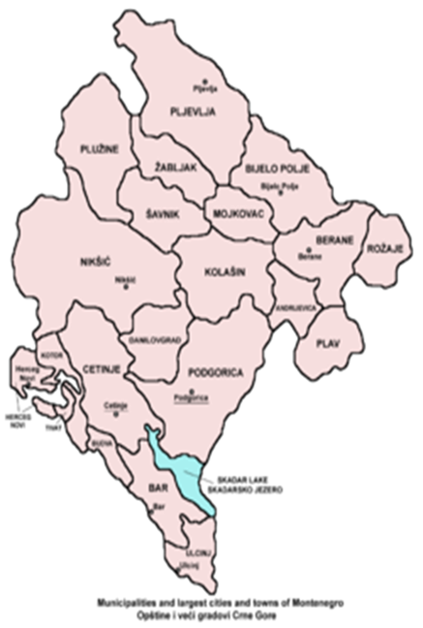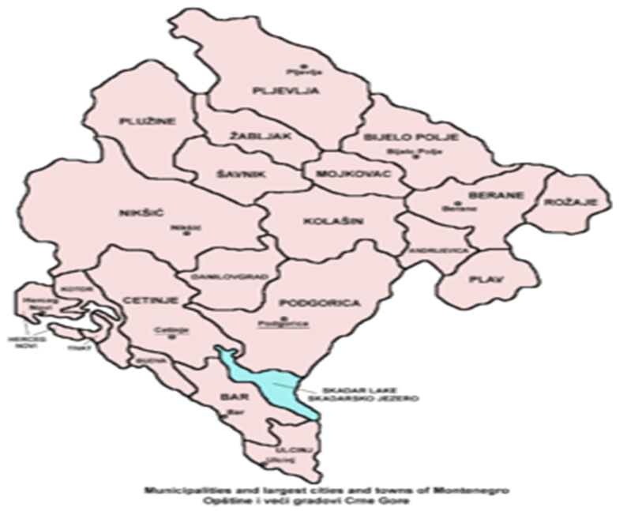
Plav
Tivat
Budva
Podgorica
Nikšić
Bijelo Polje
Podgorica
Pljevlja
Herceg Novi
Bar
Bar
Budva
Podgorica
Nikšić
Bijelo Polje
Picture no. 1. Visits to teachers in first, second and third round of training
Additionally, each teacher could, after completion of the training, give their opinion of the training, the skills acquired, the usefulness of the training, the employer's requirements and the novelty they would use in the practical lesson, filling out the questionnaires at the end of this report.
Among other things, the teachers had the task of evaluating the usefulness of the training from 1 to 5, and the result of the overall analysis is presented in the following graph.

Scale of measurements: 1-lowest rating that refers to evaluation of usefulness of training (not satisfied, not helpful); 5-Highest grade of evaluation of usefulness of training (training was very useful)
From total of 98 teachers who attended the training, 72 teachers evaluated the training with the highest rating, and we can conclude that the training for most teachers was very useful and that the teachers were satisfied with the assigned employer, the way of transferring knowledge and skills as well as the requirements with which they met during the training.

- Recommendations for improvement
Teachers also had the opportunity to give their suggestions on the implementation of the next training. The analysis found that the following should be done:
• duration of training
- Most teachers believe that a one-week period of 5 working days is not enough to get familiar with all the segments of that job, and it is proposed to extend training for at least two working weeks.
• relieve teachers during training
- All teachers should be relieved of classes during training because training represents a workload of 8 hours per day. Some schools have succeeded in getting teachers out of the classroom this week, while in most schools, teachers spent the five working days both at school and at the employer.
• engaging training with an employer in other developed cities
- There are small towns here that do not have an attractive employer in their offer to transfer their knowledge to the teacher; In this connection, it is essential for these teachers to provide employers from developed cities.
• point to better co-operation between schools and employers
- Coordinators are not always able to know in advance what kind of practical experience a certain teacher is in, and it would be desirable for a teacher to be included in the employer's choice to make the training more efficient. It is necessary that different assets lead more frequently to this topic.

Teacher training as a form of vocational training should be part of the educational system in Montenegro. More and more teachers will attend training and improve and, as an additional motivation is the certificate of training completed at the end of the training. This certificate gives the teachers a certain number of credits recognized in the process of issuing a license or giving a higher vocation. However, there is a question of co-operation between schools and employers, as the interests of schools, which aim to provide training for teachers and employers, are to be met, with the aim of gaining benefits for their company.
Namely, the expected cost / benefit ratio during training is an important deciding factor for offer the practice in companies, where benefits cannot qualify only through productive results. Therefore, as a form of motivation for employers to include as much as possible in the implementation of the training, they cite the tax incentives that would require the involvement of the Government of Montenegro.

- Questionnaires and forms
APPLICATION FORM
Instructions for filling:
- This form is filled in by vocational school teachers
- The training is part of the continuous professional development of teachers and should be organized in agreement with the organizer of practical education and the school director
Name

Surname

City

Name of school

Title of subject
Field of training

Employer

Training period | From: |  | To:
Note:
Application form must be signed by teacher, coordinator of practical classes and school prinicpal
Teacher:  Tel no. .......................................  E-mail: ......................................  Date: ......................................  Signature:  ........................................... |  | Coordinator of practical classes:  Name and surname:  ..................................................  Tel no.  .......................................  E-mail: ......................................  Date: ......................................  Signature:  ........................................... |  | Prinicpal of school:  Name and surname:  ..................................................  Tel no. .......................................  E-mail: ......................................  Date: ......................................  Signature:  ...........................................

QUESTIONNAIRE
Instruction for filling:
- This questionnaire is fiiled by teachers after the ending of training
- Questionnaire must be filled electronically and submit it to the organizer of practical education at the school
Name

Surname

City

Name of school

Title of subject

Name of employet

Address:

Instructor:

Tel.no. of Instructor:

E-mail of instructor:

The tasks you performed during the training

Skills that you acquired during training:

What are the requirements of the employer you are not expecting?
What will you suggest to change in the practical class of the subject you are teaching?

Score from 1 to 5 to evaluate how satisfied you are with the employer / instructor.  1-least satisfied  5-most satisfied |  | 1 2 3 4 5
Score from 1 to 5 to evaluate the usefulness of training.  1-least satisfied  5-most satisfied |  | 1 2 3 4 5
Your suggestion for improving training in the next cycle
Signature of teacher

