Pathfinding for Professional Development for vocational teachers and trainers through virtual networking and digital and on line learning (DOL)

Deliverable 2 – evaluation of NETWORK provision and recommendations for development

Country: TURKEY

Acknowledgements
The ETF acknowledges the contributions of School Principals and teachers, university researchers, MoNE officials, training providers and platform managers to this draft report.

Introduction
The project “Pathfinding for Professional Development for vocational teachers and trainers through virtual networking and digital and on line learning (DOL)” has been embarked upon by the European Training Foundation (ETF) in order to achieve the following strategic goals in Turkey, Serbia and Albania:

- Identify and engage partners, contributors, institutions and authorities in the use of virtual networks for the professional development of vocational teachers;
- Identify Open Education Resources (OER) and practice that could be included and shared on a virtual network or platform;
- Determine the scope and focus of a pilot virtual network;
- Promote understanding of blended learning across the three countries;
- Identity and share international good practices in the building and operation of virtual networks;
- Provide support to key national agencies.
In Turkey this projects supports Policy Option 2 identified in the Ex-Ante Impact Assessment Report which followed up the Riga Conclusions.

MAPPING OF NETWORKS FOR VOCATIONAL TEACHERS:
Based on the results of interviews and a search of related web-sources, the initial findings regarding the online platforms available for VET Teachers are as follows:
- EBA (Education Knowledge Network) was found to be the most popular online source for most teachers and school principals. One reason for this is that the Ministry of National Education (MoNE) is promoting the use of EBA for all teachers and students. EBA receives 130,000 daily logins, but only 1,200 are from VET teachers and 11,000 are VET students. Of the 1,200 VET teachers, 200 use subject-matter-related content and 1,000 use e-content on STEM. Even though EBA is considered the most popular and reliable online learning portal by those VET teachers consulted, it’s still regarded as an inadequate learning platform for both VET teachers and students.
- There are many online communities for VET teachers which serve only teachers working in a particular school
- Facebook and WhatsApp are the most common type of social media used by VET teachers.
- A few VET teachers use Moodle as a Learning Management System. Most Moodle sites are set up and managed by individual teachers rather than institutional support.
- Most VET teachers use online communities to download lesson plans and teaching materials. Another motivation for VET teachers to use online resources is to receive up-to-date news about regulations.
- Unfortunately, teachers mostly utilize online resources for administrative purposes rather than instructional purposes or for their own professional development.
- In VET schools, the quality of internet access and online resources available for teachers is determined by the school’s social economic status (SES), the Parents-Schools Association, and private sector donations and endowments. However, most VET schools fail to initialize such a level of cooperation with the private sector.
- Most VET teachers stated that MoNE should play a key role in the establishment and management of online resources for teachers’ professional development.

EVALUATION OF SELECTED NETWORKS
In this section three different platforms are considered are examined in order to learn from their achievements and to consider how this good practice can serve vocational teachers.

1 EBA (Education Knowledge Network). http://eba.gov.tr

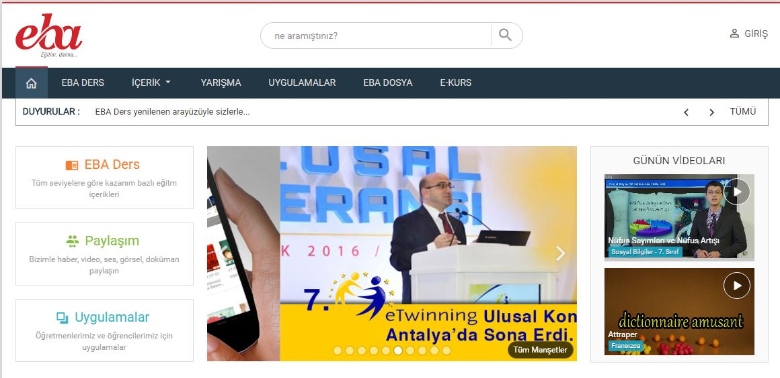

EBA is the learning portal developed under the FATIH project. EBA aims to provide high quality content in various forms (e.g. picture, audio, video, simulation) to both students and teachers as a means of fostering teaching-learning process quality.
Predominantly, EBA content is donated by the private sector, NGOs, and public institutions such as universities, with additional considerable effort from the MoNE to design and develop its own content.
Currently, there are 63,828 visuals, 16,368 videos, and 5,940 audios, with 30 different educational portals for teachers and 77 portals for users, and 2,200 e-books presented to 12.2 million registered users.
EBA receives 130,000 daily logins, but only 1,200 are from VET teachers and 11,000 are VET students. Of the 1,200 VET teachers, 200 use subject-matter-related content and 1,000 use e-content on STEM. Even though EBA is considered the most popular and reliable online learning portal by VET teachers, it’s still regarded as an inadequate learning platform for both VET teachers and students. EBA includes the UZEM (Uzaktan Eğitim Merkezi – Distance Learning Centre) which is intended to offer distance learning for teachers. However, it is not currently functional.

Strengths of EBA
- Government supports EBA.
- Almost all teachers within the system are aware of EBA.
- All subject matter areas are covered under EBA.
- 24x7 technical support is available.
- Content is continuously updated.
- Many NGOs and much of the private sector donate content to EBA.
- It is a content sharing portal for both teachers and students.
Weaknesses of EBA
- It is too centralized.
- No special focus for VET.
- It doesn’t encourage teachers or students to produce their own content.
- Sustainability largely depends on the FATIH project.
- No special emphasis on VET teachers’ professional development (although some linkage is planned for the future).

Conclusions
EBA is the best known and most widely used teacher network in Turkey. It is well resourced, backed by the MoNE and benefits from technical and administrative support.
It could serve Turkish vocational teachers better if there were more content and services that target vocational teachers, if there was better linkage with face to face professional development and if there were more scope for peer to peer communication and more encouragement for resource sharing and co-development.

2 E-Kampus (Teacher Academy Foundation)

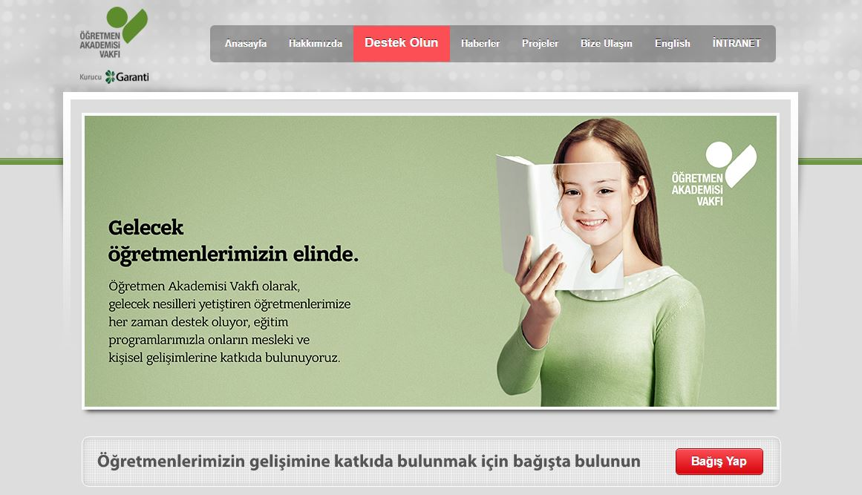

In 2008, the Teacher Academy Foundation NGO was established by the Garanti Bank in order to provide sustainable and continuous professional development training for teachers; with over 125,000 participants since inception. There are currently nearly 107,000 registered users, with 104,000 active users.
The primary goals of the foundation are:
- To serve in every way for the development of teachers in Turkey, enhancing their capacity to raise the next generation, and to help them reach a level of recognition and esteem they deserve in society.
- To respond to the needs of teachers who have the primary responsibility and utmost important duty of raising new generations to achieve high academic and ethical standards. These generations of young people need to be raised with an awareness of their individual and social responsibilities; to be probing, inquisitive and capable of analytical thought and self-confidence. The foundation seeks national and international partnerships to reach its goals.
(http://www.orav.org.tr/en/aboutus.aspx)

E-Kampus is the learning platform (LMS) of the Foundation. In their 2015 activity report, it was reported that all teachers who complete face-to-face (f2f) training are given access to the e-Kampus platform in order for them to continue their training. The e-Kampus platform also provides a structure for “communities of practice”, by bringing teachers together around the same subject in order to exchange experiences.

Strengths of E-Kampus
- There is strong financial backing (Garanti Bank).
- Face2face and online training are coordinated
- A professional team designs and develops the instructional models.
- Sustainable and continuous monitoring & evaluation.
- Targeted at the general pedagogical skills of teachers.
- High quality content is provided.

Weaknesses of E-Kampus
- No special focus for VET teachers.
- Only 0.1% of teachers share their knowledge with others.

Conclusions
E Kampus is a popular, professionally managed online network which is well linked to face to face professional development. It provides a good example of how face to face learning can be blended with on line learning.
In order to address the needs of vocational teachers, ORAV could produce more content and OERs that are targeted to the needs of vocational teachers and encourage vocational teachers to share teaching and learning materials with one another.

3 Meslek Öğretmeni: http://www.meslekogretmeni.com

Established by a VET teacher (Sebahattin Havuş) in 2006, Meslek Öğretmeni is a portal for the exchange of lesson plans and course material (especially ppts) among VET teachers of all subject area disciplines. This website receives nearly 6,000 single visits at the beginning of academic semesters, and 1,500-2,000 single visits each day. A login system was in use when it was first launched, but that was abandoned due to lack of a technical team and support. Since 2006, 3,310 documents have been shared on the site. Office management, Marketing, Accounting, Child development, Clothing Production and Catering are particularly well resourced.

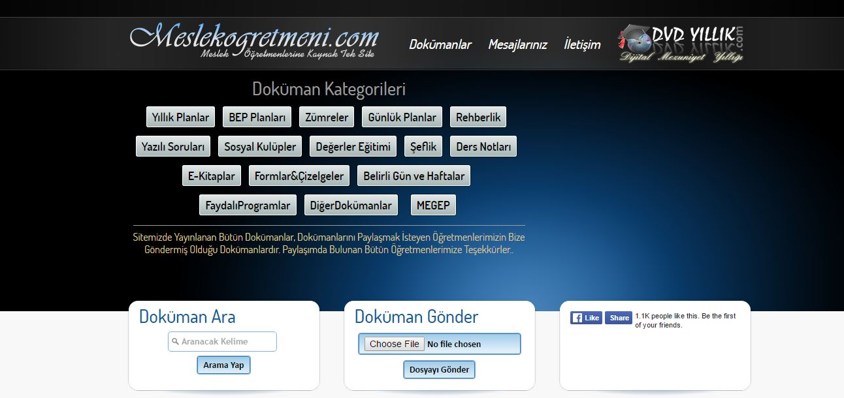

Strengths of meslekogretmeni.com
- It is one of the most used online resources by VET Teachers.
- It is an individual initiative run by a VET teacher (Selahattin Havus).
- Covers all VET subject areas.

Weaknesses of meslekogretmeni.com
- There is no technical or pedagogical support.
- Its main purpose is for content sharing (lesson plans & course presentations).
- There is no login data kept by the system.
- All content is self-uploaded by VET teachers, so there is no quality check or quality assurance.
Conclusions
Meslekogretmeni.com is the single most popular website (in terms of daily visits) for vocational teachers in Turkey. Despite the lack of full-time technical or administrative support it has attracted a large passive and active user base.
Its value to vocational teachers would be increased if it could be linked to face to face training opportunities, if it included peer-to-peer communication and if technical and pedagogical support could be provided.

Recommendations for Potential Networks in Turkey
Current Situation
The Mapping Report on On-line Networks for teachers reveals a relatively mature but complex landscape. We can distinguish three types of network:
- Official, MoNE owned platforms such as the EBA, MEGEP and mebdeogren.meb.gov.tr. These are generally well funded and administered. They function largely as top-down repositories of teaching, learning or curriculum materials with some e-learning but with little peer2peer networking or sharing and not much integration with other services, e.g. news, face2face events. With the exception of MEGEP, the current platforms do not particularly address vocational teachers.
- Intra-school networks and ‘teacher owned’ networks usually operating through social media, such as Facebook. There are many such networks and they appear to focus mainly on communication and building communities of practice. Short term national and international projects may also construct social media networks for their participants, using Facebook, Google or WhatsApp. Such small networks benefit from having identified audiences and relatively high levels of trust.
- Large ‘project platforms’ which may be owned by Foundations and/or supported by a Ministry, for example, the Teachers Academy Foundation’s (ÖRAV) E-Kampüs platform, Vitamin Öğretmen (operated by Turkish Telekom), Bahceshir University’s http://stem.bahcesehir.edu.tr/index.html. Some of these platforms offer both a repository function, and also support on-line discussion and e-learning. Other teacher platforms such as Haceteppe University’s http://www.bilimiletisimi.com/en offer educational materials gathered from the on-line press while project websites such as Bahceshir University’s http://stem.bahcesehir.edu.tr/index.html serve mainly to disseminate project news, events and publications. Usually, these platforms are sometimes well funded and benefit from technical and administrative support. Currently it is not clear that, in practice, these platforms are successful in facilitating peer2peer learning rather than top-down communication – active participation appears to be modest.
While these platforms have relevance for vocational teachers they are mainly focused on other kinds of teachers. There is not currently a well-established, well-funded and officially endorsed national platform for vocational teachers in Turkey. However, there are some local, project-related or teacher driven platforms, such as Meslek Öğretmeni, which do attract participation.

A Strategy for Networking Vocational Teachers in Turkey
There are already a significant number of networks for teachers in Turkey, some large and others small, with different ownership and scope. Vocational teachers are relatively neglected. It makes sense to address the needs of vocational teachers by building upon and learning from the successes and limitations of existing provision. Policy makers and stakeholders should not be limited to a single method of supporting networking – they should consider how multiple methods can complement one another and encourage the ongoing development of on-line communities for professional sharing, development and collaboration. It should be remembered that while it is possible that different functionalities can be combined within a single platform, it may be more practical and acceptable to vocational teachers if different functionalities are distributed across different platforms and media. For example, a large repository may be complemented by social media groups which are smaller where it is possible to develop a community with higher levels of interaction.
Policy makers and stakeholders should consider the following areas of action:
- Existing official Ministerial platforms and larger ‘project platforms’ might be encouraged and supported to provide more content and services directly for Vocational Teachers. They could also increase their functionality, for example, to facilitate more peer2peer learning and more blended learning, for example, by linking to face-to-face training events. Such developmental work could be supported by encouraging partnership and collaboration, for example, with providers of teacher training programmes. It may be possible for platforms to address both vocational and general teachers, for example, in the areas of STEM and language learning.
- Smaller, teacher and project-owned networks that address vocational teachers could be supported. Support might take the form of small grants, advice, standards, marketing, public recognition or meta-networking.
- A specialized sectoral and/or Provincial pilot network could be supported to act as pathfinder. Such a pilot could build upon an existing network. It could also seek to include other partners such as business and higher education and local government authorities. Related to examples of Science and IT Networks.
- A portal and a meta-network could be created to market other networks and websites that are relevant for vocational teachers, to share good practice and encourage sharing and innovation.

Recommendations for identified stakeholders:
VET General Directorate, MoNE
- Work with other Ministries, GDs, Foundations, Projects and business to ensure that, where appropriate, existing and future on-line platforms do also address needs of Vocational Teachers
- Provide support and links and raise awareness of virtual platforms for vocational teachers. Consider developing the platform which it owns, http://www.megep.meb.gov.tr/, to increase its functionality and/or to make connections with or raise awareness of other platforms and networks for vocational teachers

Teacher Training General Directorate, MoNE

- Consider how teacher training, whether delivered by TT GD or by contracted providers at national or provincial levels, may be linked to on-line communities in order to offer blended professional development
- Work in partnership with VET GD for vocational teachers to support the development of blended learning on existing platforms

Owners of existing platforms addressing teachers

- Consider and research how the needs and interests of vocational teachers can be better addressed
- Encourage peer- and blended-learning as well as top-down communication, for example, by linking small social media networks to larger platforms

The ETF
- Showcase and support learning from concrete networking practice for vocational teachers, for example, from Demonstration Projects
- Provide timely advice and expertise to those leading and planning networking and try to empower vocational teachers to take advantage of networking opportunities
- Support cooperation, learning and collaboration between stakeholders and practitioners, for example, through meetings, webinars, paper

ETF (2016) Ex-ante impact assessment report - Turkey
ETF (2017) Deliverable 1: Draft Mapping of Provision of On-Line Networks for Vocational Teachers
The FATİH project is implemented by the Ministry of National Education in cooperation with the Ministry of Transport, Maritime Affairs and Communication. There are five components in the project: 1. Provision of a hardware and software infrastructure; 2. Provision and management of educational e-content; 3. Effective usage of ICT in education programmes; 4. In-service training of teachers; 5. Conscious, safe, manageable and measurable ICT usage. At this point in time, VET schools are not included within this project.
The Bilgeis project – which addresses employers and employees – intends to provide a platform for e-learning: http://proje.bilgeis.net/en/#home
Data is not currently available.

