Strategic Project on VET Provision: Continuing Professional Development of VET Teachers and Trainers
Pathfinding for Professional Development for vocational teachers and trainers through virtual networking and digital and on line learning (DOL) in Montenegro

MONTENEGRO

Deliverable 2: Identification and recommendations for potential pilot network(s)
Country: Montenegro
Author: Slavica Dimovska
Date: August, 2017

Contents
INTRODUCTION 3
EVALUATION OF SELECTED NETWORKS 4
NETWORKS TARGETING GENERAL PUBLIC AND PROFESSIONALS (ALL EDUCATION STAFF) 5
1 School Portal – Portal for Teachers (Skolski portal) 5
2 Bureau for Educational Services (Zavod za skolstvo) 8
NETWORKS FOR A PARTICULAR INITIATIVE OR PROJECT 11
3 Service Centre for Training Firms (Servis centar preduzeca za vjezbu) 11
4 Online Platform Entrepreneurial School (Online platform Preduzetnicka skola) 13
SCHOOL LEVEL NETWORKS AND WEB-SITES 15
5Secondary VET school “SpasojeRaspopovic” Podgorica (Srednjastrucnaskola “SpasojeRaspopovic”) 15
6 Secondary and post secondary VET school “Sergije Stanic ”Podgorica (Skola za srednje i vise strucno obrazovanje “Sergije Stanic”) 18
RECOMMENDATIONS FOR THE POTENTIAL PILOT NETWORK(S) 20
Recommendations in relation to national platforms that target all vocational teachers 20
Recommendations in relation to national platforms that target special initiatives, e.g. training firms, enterprise education 21
Recommendations in relation to school platforms 21
Other Considerations 21
Some Options for ETF to support developments in Montenegro 22

INTRODUCTION
The start of the 21st century has witnessed significant changes in the way people access, use, and create information and knowledge, due in many ways to the ubiquitous availability of ICT. This global change have significant effects on how people live their personal and working lives, and hence have effects on the teacher training systems that support professional development of VET teachers.
In the current global economy, learning through digital networks and the use of digital media, is becoming increasingly important in private life, in learning, and in professional life. The ETF project Strategic Project on VET Provision: Continuing Professional Development of VET Teachers and Trainers - Pathfinding for Professional Development for vocational teachers and trainers through virtual networking and digital and on line learning (DOL) in Montenegro aims to support the development of effective and sustainable virtual communities for the professional development of vocational teachers in Montenegro. The project team worked together with key actors and stakeholders in order to build upon current capacity and aspirations to analyse the existing situation and to examine the most adequate solutions for development, extension and enrichment of the Web-based Platforms and Networks in Montenegro that support professional development for vocational teachers and trainers.
This report summarizes results from a portion of Phase 2 work, on the “Identification and recommendations for potential pilot network(s)”. The data were collected during July and August 2017. The paper concludes with a discussion of ideas towards the reporting of the outcomes for the potential Web-based Platforms and Networks for VET teachers in Montenegro.
Acknowledgements: We thank the Ministry of Education, Center for Vocational Education, Bureau for Educational Services, Secondary VET Schools “Spasoje Raspopovic” Podgorica, and Secondary and Post-Secondary VET School “Sergije Stanic” Podgorica for their support and creative input for the work reported in this paper.The views and opinions expressed in this paper are those of the author alone.

EVALUATION OF SELECTED NETWORKS
Professional development through virtual networking and digital and on line learning (DOL) might happen in different forms, depending on the role and the action VET teacher will undertake. A person might limit themselves to be only a consumer in a network or user of available web-resources, or to be involved as a producer or active contributor in creating the information, news and/or development of resources and exchangeable materials, and a teacher that participates in the development of social capital through networks:
- Functioning as a consumer in networks or user of available web-resources involves obtaining, managing and utilizing information and knowledge from shared digital resources.
- Producer – active contributor involves creating, developing, organizing and re-organizing information and knowledge in order to contribute to shared digital resources.
- Developing and sustaining social capital through networks involves using, developing, moderating, and leading the connectivities within and between individuals and social groups in order to marshal collaborative action, build communities, maintain an awareness of opportunities and integrate diverse perspectives.
The online research and consultation process with key Montenegro stakeholders performed by Expert resulted in the detailed list of the relevant professional networks and source web-sites that were or are in use in the country. Analysis suggests that we can distinguish four main types of website in Montenegro:
Ownership and operation | Scope and audience
Government or national agency | National: across teachers and subjects
Initiatives and Projects (managed by national agency) | Those teachers involved in an initiative, project or particular profile
Schools | Teachers, students and parents of that school
Groups of teachers | Teachers that share an interest, e.g.a Facebook group

The analysis that follows draws examples from the first three types.

NETWORKS TARGETING GENERAL PUBLIC AND PROFESSIONALS (ALL EDUCATION STAFF)

1 School Portal – Portal for Teachers (Skolski portal)
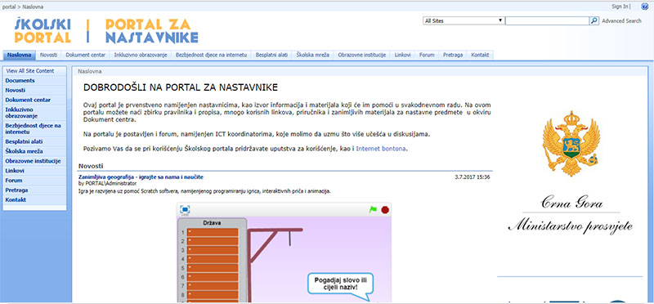
Figure 1. Screenshot from “Skolski portal“
School Portal – Portal for Teachers (Skolski portal) www.skolskiportal.edu.me is a platform targeting all teaching and non-teaching staff from Montenegro elementary and secondary educational institutions. The purpose of the portal is to support improvement and popularity of the ICT in schools, which will contribute to the overall boosting of the ICT knowledge and skills level in society. The key purpose of the portal is to provide teachers the opportunity to publish materials and resources, to exchange ideas for teaching and learning process improvement, as well as lectures and professional experience. The portal aims to enable systematic and permanent exchange of ideas, knowledge and professional experience of teaching staff, to encourage teachers to use Internet in their professional work, to support introducing new technologies, as well as to contribute innovative work in different educational sectors.
The portal is topic oriented and consists of categories and sub-categories providing thematic news, articles, reports, downloadable publications, tools and guides, video material, good-practice examples from schools and web-links for ICT coordinators and education professionals from elementary education, secondary general and VET education. Depending on the topic, subject and/or sector, the amount of available content is unequal, i.e. no content in some areas (subjects and or sectors) while in areas ICT (secondary general), Physics (elementary) and VET sector Tourism and Catering there are significant number of good practice examples, lectures, assessment tools, etc.
All portal visitors are enabled to download resources available while only portal administrators and authorized ICT coordinators in schools are allowed to publish materials. The administration and hierarchy is pre-defined and divided among ICT department in the Ministry of Education and Regional and school ICT coordinators. ICT coordinators are main contributors in publishing content at the portal. They are the key personnel responsible for implementation of the ICT policy in schools and, among other, to promote the portal and educate teachers to use the portal.
- Participants
Each elementary, secondary general and VET school has an ICT coordinator responsible to represent its school. In addition, 16 regional coordinators (8 central region, 3 south region and 5 north region are involved in publishing resources).
- Network Coordinator
The management, maintenance and administration are undertaken in the Ministry of Education (ICT department).Furthermore, Bureau for Educational Services and VET Centre also has representatives involved in publishing resources and materials at the portal.
Forum
As listed above, a category Forum is included at the portal. The Forum aims to offer support to school and regional ICT coordinators in their everyday work, to foster inter-school cooperation in the area of ICT and to help ICT coordinators resolving ICT related problems in schools. It is moderated by ICT department in the Ministry of Education. The forum is not open to teachers and other non-teaching staff from schools.
- Focus
Skolski portal is mainly focused on provision of information, news, events, examples of good practice and resources for elementary, secondary general and VET teachers. In addition, focus is on communication between ICT department in the Ministry of Education representatives, school and regional ICT coordinators.
- Potential for Blended Learning
At the moment, trainings are not available. There are more than 2000 units of digitized material (textual, video, etc.) available to all potential users of Skolski portal.
- Institutions
A network of institutions (their representatives) is involved and is contributing to the Skolski portal development:
- Ministry of Education
- Elementary, secondary general and VET schools
- Bureau for Educational Services
- VET Centre
- Technical Media
The portal was established by ICT Department in the Ministry of Education, ITAS Company and Ranko Cabrilo, former principal of the Secondary VET School “Ivan Goran Kovacic” – Herceg Novi, and in cooperation with Microsoft. It is a result of custom software development where all functionalities are specifically designed and developed in order to address the specific needs set by the Ministry of Education.ICT department in the Ministry of Education and Sciences has a specialist maintaining the portal on a regular basis.
Strengths:
The portal is hosted at the Ministry of Education server which doesn’t include any further funding requirements. Administration is shared between Ministry of Education, regional and school ICT coordinators.
Established network of key national stakeholders – Bureau for Educational services, VET Centre and elementary, secondary general and VET schools
The majority of key stakeholders interviewed recommended to further improve Skolski portal to serve professional development needs of VET teachers and trainers
Quality assurance mechanisms are in place regarding content publishing and there is shared responsibility among Ministry of Education, regional and school ICT coordinators
Significant numbers of teachers are already consuming currently available content from Skolski portal therefore, possesses potential for promotion of newly integrated functions and attacking new users
Weaknesses:
Forum is used only by ICT coordinators and representatives from ICT department in the Ministry of Education
Absence of data on numbers of users, downloads, documents which is an issue in proposing the potential further improvement/re-design
Some subjects/VET sectors well supported (Tourism and Catering, ICT, etc.), while, some VET sectors and/or subjects aren’t supported at all
Portal doesn’t offer functions to support teacher’s networking (discussion pages, chat rooms, etc.)
Professional development training/courses are not included
Widgets that allow connections to social media are not available
System is not designed to allow teachers to set up and administer groups, to “meet” online, answer questions and discuss various topics of professional interest
LMS and online conferencing system that allows for webinars and online meetings is not integrated
Recommendations/CONCLUSIONS
The existing partners – Ministry of Education, Bureau for Educational Services and VET Centre would need to establish a permanent working group/advisory body to coordinate the development of this portal
Skolski portal needs to be re-designed and upgraded to fully serve the professional development needs of teachers.
The platform could cover all levels of education (elementary, secondary general, VET) and all subjects – if appropriate and relevant content can be made available.
Relevant institutions could each take responsibility for their part of the platform (VET Centre for VET related area, Bureau for Educational Services for secondary general, elementary schools and kindergartens, etc)
In order to encourage teachers to use the platform, contributions and participation might be considered and recognized for the formal teacher advancement procedures
The upcoming revision of the legislation/regulation of the formal teacher advancement procedures would need to recognize the web-based professional development for teachers
Quality assurance of the content proposed for publishing from a particular school could be undertaken by portal administrators or Professional Section of Teachers
The functionality to enable sharing and exchanging materials and resources, interactivity among members, and to offer webinars and online courses
It would be useful for design a guide for publishing the materials and resources
Options for linking this portal to developments in distant learning and video conferencing should be explored

2 Bureau for Educational Services (Zavod za skolstvo)
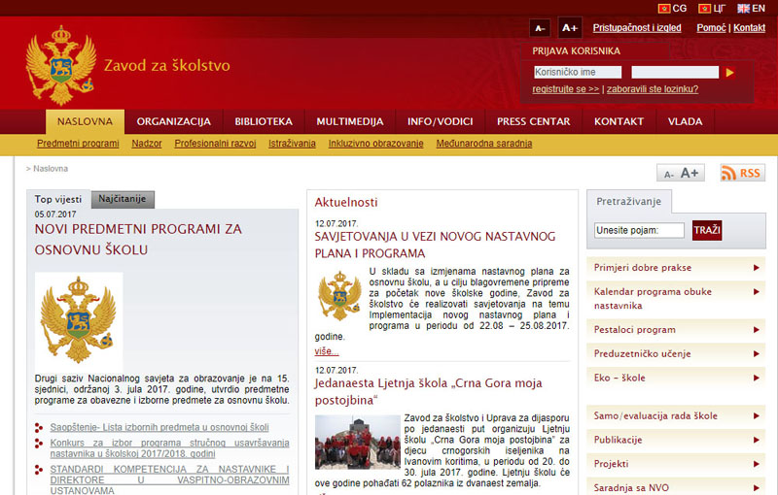
Figure 2. Screenshot from “Zavod za skolstvo“
Bureau for Educational Services (Zavod za skolstvo) http://www.zzs.gov.me is the main web-site of the Bureau for Educational Services. The Bureau for Education Services is a government institution responsible for improving the overall quality of education at all pre-university levels of general education and general part of the curriculum for VET‐ preschool, primary schools, secondary schools (gymnasiums, vocational education) as well as in students’ dormitories and Resource Centers for children with special needs. The Bureau has research, advisory and development-oriented functions in the reform of the education system.
The Bureau organizes seminars for school principals and coordinates workshops for the professional development of teachers on a regular basis.
The web-site has pre-defined structure, developed and hosted by Government of Montenegro department for Public Relations. Their target audiences are general public, education professionals, parents, students and all relevant stakeholders in country and abroad. In that sense, the web-sites offer various types of information, news, events, and resources. The purpose of the portal is to provide transparent information about the activities undertaken, and to support everyday work in educational institutions by providing resources and materials.
The web-site has pre-defined structure that is uniform for all web-sites hosted at the Government of Montenegro server. The institution doesn’t have the opportunity to modify this main categories structure.
The web-site is further segmented by grouping content per tailored sub-categories relevant for the specific institution (e.g. Teaching Subjects, Educational supervision, Professional Development, etc.)For the purpose of this paper, the category Library is particularly interesting as it offers various types of content related to: teaching subjects, professional development of teachers, catalogs, strategies, tenders, topics focusing specific projects/programmes implemented in Montenegro (i.e. Pestalozzi Programme), Other topics, and Bureau for Educational Services Reports. Each of above mentioned sub-categories consist of thematic news, articles, reports, downloadable publications, legislation papers, regulation, and tools and guides.
In addition to this, web-site offers content for per specific professional areas: good practice examples, professional development calendar, self/evaluation of educational institutions, projects, publications, cooperation with NGO sector, each of those consisting of mainly textual downloadable content, news and information.
- Participants
General public, education professionals, parents, students and all relevant stakeholders in country and abroad. All web-site visitors are enabled to download resources available while only web-site administrators (Nevena Cabrilo, Andjela Kadovic, and Danijela Đilas) are allowed to publish content and materials.
- Network Coordinator
The web-site is technically maintained by Government of Montenegro department for ICT support and PR, while web-site administrators are autonomous in publishing content and are responsible to Bureau for Educational Services management.
- Profile of Teachers/Trainers
Teachers from preschool, primary schools, secondary schools - gymnasiums, vocational education, students’ dormitories and Resource Centers for children with special needs.
- Focus
Web-site is by its nature, the communication channel with the purpose to inform target audiences about the activities in the areas of preschool, elementary, secondary general and general part of VET education. Its main focus is provision of information, news, events, examples of good practice and resources.
- Potential for Blended Learning
Although detailed information about the professional development options is available (news, events, articles, calendar, supporting materials, etc.) on line trainings are not available. There are more than few thousands units of digitized material available to all visitors of web-site.
- Institutions
The institution responsible for web-site development is Bureau for Educational Services
- Technical Media
The portal is a result of custom software development and has uniform and pre-defined structure for all ministries and governmental agencies. The web-site allows administrator to upload different types of textual resources, photos and video, to publish news, articles and info. The LMS and conferencing system isn’t integrated, as well as functions that support interactivity.
Strengths:
The portal is hosted at the Government of Montenegro server so it does not lead to additional costs. Administration is an established responsibility of the Bureau.
Clear and defined maintenance and administration hierarchy and structure
Many pre-university teachers (pre-primary, primary and secondary general education) are already consuming currently available content from web-site
Web-site serves as the main hub for all education related news, information, events and resources related to general education
Weaknesses:
Little content specifically targeting VET teachers. Most of the available resources are grouped per topic/area
Limited number of good-practice examples from VET schools available
Limited or no information about the professional development opportunities available (or other portals) other then the activities undertaken by Bureau
Recommendations/CONCLUSIONS
Bearing in mind its main purpose to serve as main information and communication channel, the web-site is well structured. However, it might be good to consider some re-categorization of the existing content and resources to allow easy access
To expand the section for professional development options for general subject teachers in VET
To expand the section for good-practice examples and other related exchangeable materials
Explore how the site could support face to face CPD provision, for example, by sharing learning and resources
Bureau for Educational Services web-site provides the content related to the good practice examples. This might be considered as a new category or a topic on the VET Centre web-site focusing VET related subjects.

NETWORKSFOR A PARTICULAR INITIATIVE OR PROJECT

3 Service Centre for Training Firms (Servis centar preduzeca za vjezbu)
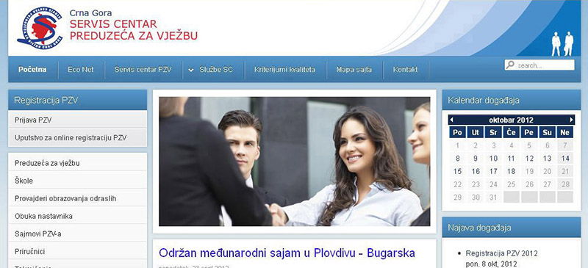
Figure 3. Screenshot from “Servis centar preduzeca za vjezbu“
The Service Centre for Training Firms (Servis centar preduzeca za vjezbu) www.serviscentarpzv.me was established in June 2005 by Center for Vocational Education within ECO NET Project. ECO NET Project (promotion of Training Firms in South Eastern Europe) was implemented by Kultur Kontakt Austria with funds provided by the Austrian Development Cooperation & Cooperation with Eastern Europe and the Federal Ministry of Education and Women's Affairs. The project was implemented in cooperation with Centre for Vocational Education of Montenegro.
The implementation of ECO NET was begun in 2004 with the aim of supporting practice-oriented economic education in Montenegro. A training firm is an innovative form of instruction which promotes practice orientation and entrepreneurial thinking to the greatest possible extent and makes the processes of real businesses transparent for the learning process. During the lifetime of the project the teachers/trainers were offered in-service face-to-face training in various areas of professional development – modern pedagogy, ICT skills, specialized didactics for VET sector, etc. Training Firm is implemented in more than 20 VET, higher and adult education institutions in Montenegro.
The main function of the Service Centre is to provide real business environment to training firms, by assuming the role of institutions with which actual companies cooperate (central register of business entities, tax administration, bank, insurance funds and similar), and to support improving and promoting entrepreneurial learning in secondary schools. The web-site is the key hub for information and resources to support teachers/trainers implementing the curriculum, as well materials and templates students are using in training firms.
Web-site aims to support boosting national training firm network, promote the training of multipliers, intensify cooperation with the business sector and organize national and international fairs. Training firm fairs give the participating students and teachers an opportunity to network with partner firms in Montenegro and abroad.
Although the functionality of this website is limited it does provide information and resources for a particular project network. This offers a model for one strategy for developing networks in Montenegro.
- Participants
Teachers, secondary VET students and higher education students, the unemployed persons, school management, managers of training firm centers, and policy level.Up to now, there are more than 1500 direct users/consumers of the web-site content.
- Network Coordinator
The coordinators of the Service Center and web-site administrators are Srdjan Obradović and Sandra Brkanovic, advisers in Center for Vocational Education.
- Profile of Teachers/Trainers
Teachers from secondary economic VET schools, mainly with education background in Economy or Law.
- Focus
The web-site offers general data about training firms, information, announcements related to training firms’ operations and functioning, and their interaction with other firms in the country and abroad.
- Potential for Blended Learning
During the lifetime of the ECO NET project and later, more than 100 face-to-face training sessions were organized for teachers and trainers. Majority of the resources and supporting materials are available at the web-site for teachers and trainers to support implementation. At the moment, on line courses are not available at the web-site.
- Institutions
The institution responsible for web-site development is Center for Vocational Education.
- Technical Media
The portal is a result of custom software development where all functionalities are specifically designed and developed in order to address the specific needs of training firms defined by Service Centre coordinator(s). The web-site is hosted at the commercial server and VET Centre of Montenegro is providing funding for hosting, as well technical maintenance.
Strengths:
Clearly defined coordination structure, roles and responsibilities. VET Centre has clear administrative responsibility and has sustained website since donor funding ended in 2011.
Well known web-site among students, teachers and trainers working in a particular project and good potential for further promotion
Well structured, easy search and access for most of the resources available
Traditional training and web-site content well connected and complementary
Weaknesses:
Luck of functions allowing interactivity and direct communication among web-site consumers and/or VET Centre (Service Centre coordination personnel)
Professional development training/courses are not included
Widgets that allow connections to social media are not available
Platform is only used by special group of teachers

Recommendations/CONCLUSIONS
The web-site could be upgraded to enable discussion boards, forum, chat rooms and other functions allowing direct communication between consumers
To expand the section for supporting teaching and learning materials with handouts and manuals used during ECO NET teacher training sessions
To expand its social networking dimension with widgets that allow connections to social media which will foster the in-country and international networking
This web-site might be considered as a good practice example for other VET sectors. The most efficient approach might be to establish a joint platform for all VET sectors with the shared administration among VET advisors in charge for particular sectors

4 Online Platform Entrepreneurial School (Online platform Preduzetnicka skola)
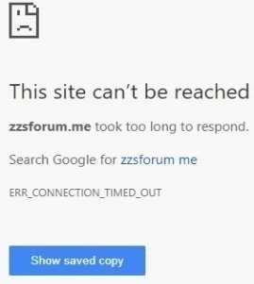
Online Platform Entrepreneurial School (Online platform Preduzetnicka skola) www.zzsforum.me is an initiative developed by Bureau for Educational Services with a purpose to enable and encourage the networking of students, teachers and schools implementing Entrepreneurship key competence in preschool, elementary, secondary general education and some VET schools. At the moment, it is a unique online platform managed by a governmental institution that possesses functions allowing direct communication and discussion among teachers and students.

The forum is topic oriented. There are 300 registered users participating in different forum discussions. It offers the opportunity for teachers to publish materials and resources, exchange ideas for teaching and learning process improvement, as well as lectures and professional experience. The portal aims to enable systematic exchange of ideas, knowledge and professional experience of teaching staff and students. In addition, resources and documents are available at the platform: national curriculum for pre-primary, primary and secondary general education, lesson plans, teaching and learning supporting documents.
At the moment limited numbers of VET schools are involved and participating in portal/forum. There is potential for upgrading the existing platform resulting in a common platform for entrepreneurship learning in Montenegro targeting all levels and types of education. The Bureau for Professional Development would like to organize a meeting with VET schools principals to present and promote the platform, as well as to investigate the potentials to motivate students and teachers to participate actively.
The platform was developed by an independent IT company which was engaged through a public procurement that Bureau announces annually. The maintenance is organized and conducted as an outsourcing work that requires additional funding for each intervention.
Due to some technical issues, the platform doesn’t function properly resulting in poor performance and limited access/delay in opening (which happen during this research). Furthermore, it is hosted on an old server that has long been out of the warranty period and should be replaced with a new server, appropriate for this purpose. From time to time the server doesn’t function due to poor electrical installations in the building, which also requires additional equipment - UPS (uninterruptible power supply) to enable proper work. Finally, the server runs on Windows 8.1 which causes interruptions in response of the platform.
- Participants
300 registered participants - students, teachers, trainers and Bureau for Educational Services advisors. Most are active participants and contributors in publishing content at the platform and forum.
- Network Coordinator
The administration and platform management is divided among Bureau for Education Services advisors Nevena Cabrilo, Andjela Kadovic and Danijela Djilas.
- Profile of Teachers/Trainers
Kindergarten teachers, General subject teachers (Mathematics, Chemistry, Foreign Languages, Art, etc.) from elementary and secondary general schools.
- Focus
Entrepreneurship Key Competence – forum and discussion board, announcements, news, events, examples of good practice and teaching and learning supporting documents/resources for elementary, secondary general and VET teachers.
- Potential for Blended Learning
At the moment, trainings are not available. There are more than 2000 units of digitized material (textual, video, etc.) available to all potential users of platform.
- Institutions
A network of institutions (their representatives) is involved and is contributing to the portal development:
- School coordinators from pre-primary, elementary, and secondary general schools
- Bureau for Educational Services
- Technical Media
The portal is a result of custom software development where functionalities are designed in order to address the specific needs set by the Bureau for Educational Services.
Strengths:
Big number of registered/involved teachers and students with potential for growth
The unique platform managed by a governmental institution supporting interactive, direct communication between involved participants and possibility to upload downloadable content
Excellent link between face-to-face training, forum discussions and documents available
Weaknesses:
Technical issues causing delay and difficulties in access
Platform is developed and maintenance by third-party commercial IT company which requires additional expenses for resolving technical issues and or/upgrading
VET schools not involved at the satisfactory level
Functions that allows on line training not integrated
Recommendations/CONCLUSIONS
Development possibilities
Online Platform Entrepreneurial School needs to be re-designed and upgraded to enlarge its capacity and to offer additional functions
To involve VET schools (at least general subject teachers)
Issues to resolve
The platform needs to be hosted at the properly working (potentially new) server
License for Windows Web Server 2012 (or later) is needed to help resolving interruptions in response of the platform

SCHOOL LEVEL NETWORKS AND WEB-SITES

5 Secondary VET school “Spasoje Raspopovic” Podgorica (Srednja strucna skola “Spasoje Raspopovic”)
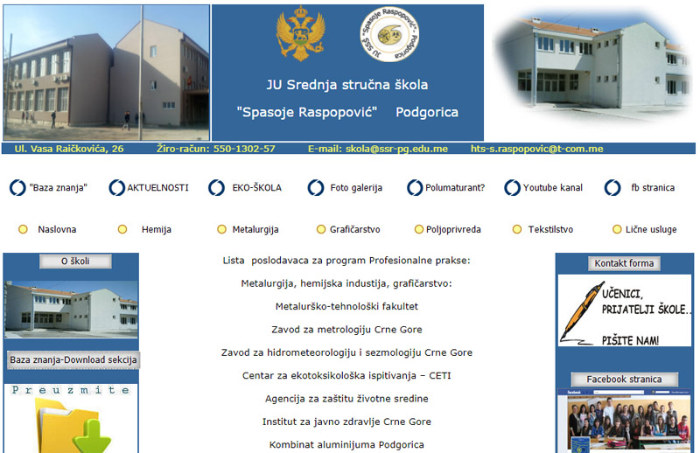
Figure 4. Screenshot from Secondary VET School “Spasoje Raspopovic“ Podgorica
The Secondary VET School “Spasoje Raspopovic” began its work 1946, as a part of the Electrical Engineering School. After the legal transformations, the school become an independent educational institution that employs more than 70 teaching and administrative staff today. The school has had an important role in the reform of vocational education in Montenegro, and was a part of first/pilot implementation of reformed VET curriculum. The continuous professional development of the teaching staff plays an important role in the overall school activities. The school has traditional classrooms and specialized laboratories/workshops for ICT, Physics, Hairdressing salon, Tailor’s workshop, Chemical laboratories, workshops for metal processing, dairy and bakery.
The school run the website (www.sraspopovic.com) and a public/open Facebook page (www.facebook.com/srednja.strucna.PG). Both, the website and the Facebook page serve as a source of information for students, parents and teachers.
Apart from the traditional content related to the activities in school, the information about the qualifications offered, the website offers the lectures from various subjects. The materials have been compiled in accordance with the curriculum, using the recommended literature.

- Participants
Teachers, non-teaching staff and school management, and school ICT coordinator Vesko Mihajlovic.
- Network Coordinator
The coordinator and web-site administrator is school ICT coordinator Vesko Mihajlovic
- Profile of Teachers/Trainers
Teachers from five VET sectors: Chemistry, Personal Services, Graphics, Agriculture, Textile and general subject teachers.
- Focus
The web-site offers info, articles, and events related to the activities in school, as well as announcements for teachers/students, international cooperation and related content of interest for general public, parents, teachers, students and local/national partners and business community. In addition, there are resources and downloadable materials for teachers, and supporting materials/lectures for students. The materials are prepared by teachers and uploaded by ICT coordinator in charge to administer the web-site.
- Potential for Blended Learning
At the moment, online courses or other content related to the professional development of VET teachers is not offered. However, the website supplements the face to face teaching in classrooms with some digital materials.
- Institutions
The institution responsible for web-site development is Secondary VET School “Spasoje Raspopovic”.
- Technical Media
The portal is a result of custom software development where all functionalities are specifically designed and developed in order to address the specific needs of the school. The web-site is hosted at the commercial server and Secondary VET School “Spasoje Raspopovic” is providing funding for hosting, as well technical maintenance.
Strengths:
Financed by school, with clear roles and responsibilities related to the content development, uploading and overall web-site management
Friendly design and easy to navigate web-site
Updated regularly with all information relevant for target groups
Categorized to maximize the visibility of the content relevant for wider society, students, potential students and parents, and all relevant information related to the five sectors - Chemistry, Personal Services, Graphics, Agriculture, Textile
The web-site is well promoted and known by students, teachers, parents and local/national partners and business community.
The social network (Facebook) page well connected with the web-site and updated on a regular basis
Downloadable lectures available for students

Weaknesses:
Content related to the professional development of teachers not available
Luck of functions allowing interactivity and direct communication either between teachers or between teachers and learners.
Recommendations/CONCLUSIONS
The web-site might need to be partially upgraded to enable discussion boards, forum, chat rooms or other functions allowing direct communication between visitors
Expand the existing content targeting teachers with more info, news, events and resources for professional development
To integrate a LMS platform

6 Secondary and post secondary VET school “Sergije Stanic ”Podgorica (Skola za srednje i vise strucno obrazovanje “Sergije Stanic”)
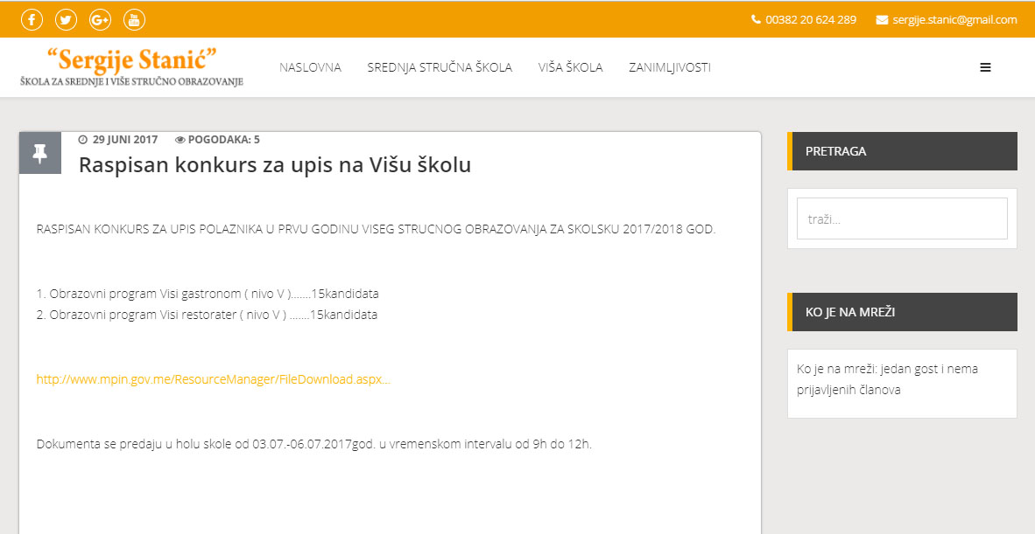
Figure 5. Screenshot from Secondary VET School “Sergije Stanic“ Podgorica
Secondary and post-secondary Vocational School Sergije Stanic www.sergije-stanic.me is an educational institution with the 50 year’s tradition. Today there are more than 1300 students who attend several curricula including: Tourism technician, Servicing Technician, Culinary Technician, Sales Technician, Chef, Waiter and Confectioner, etc. Having invested considerable funds in equipping, optimal conditions were established for the delivery of vocational theoretical and practical teaching process. The school has cabinets for servicing, cabinet for culinary, two cabinets for language training, two ICT cabinets, a cabinet for tourism technicians and a cabinet for sales technician.
The school has a very good cooperation with more than 100 social partners, including elite hotels at Montenegrin coast, where students perform practical work in respectable hospitality and trade facilities. The school owns commercial restaurant Radovce, supermarket, bakery, butchery, which are at the same time school workshops, where students do their practical work. Within the school there is also an adult education institution.
In the school there are more than 150 employees, teachers, associates in teaching process, and management members, pedagogue, psychologist, legal department, accounting department and staff of the mentioned facilities that work within the school. The school is involved in series of projects financed by international institutions and organizations.
The school run the website (www.sergije-stanic.me) and a public/open Facebook page (www.facebook.com/jusss.sergijestanic?fref=ts). Both, the website and the Facebook page serve as a source of information for students, parents, teachers, local and national stakeholders and business community.
Web site offers traditional content related to the activities in school, the information about the qualifications offered, news and events.
- Participants
Teachers, non-teaching staff and school management, and school ICT coordinator.
- Network Coordinator
The coordinator and web-site administrator is school ICT coordinator Velibor Saban, while content is developed by two employees – school PR Zorica Milickovic and a teacher Gordana Zekovic
- Profile of Teachers/Trainers
Teachers from VET sector Tourism, Trade and Catering and general subject teachers.
- Focus
The web-site offers info, articles, and events related to the activities in school, as well as announcements for teachers/students, international cooperation and related content of interest for general public, parents, teachers, students and local/national partners and business community.
- Potential for Blended Learning
At the moment, online courses or other content related to the professional development of VET teachers is not offered.
- Institutions
The institution responsible for web-site development is Secondary VET School “Sergije Stanic“.
- Technical Media
The portal is a result of custom software development where all functionalities are specifically designed and developed in order to address the specific needs of the school. The web-site is hosted at commercial server.
Strengths:
Financed by school, with clear roles and responsibilities related to the content development, uploading and overall web-site management
Easy to navigate and updated regularly
The social network (Facebook) page connected with the web-site
Weaknesses:
Content related to the professional development of teachers not available
Lack of functions allowing interactivity and direct communication between teachers or between teachers and students
Recommendations/CONCLUSIONS
The web-site might need to be partially upgraded to enable discussion boards, forum, chat rooms or other functions allowing direct communication between visitors
Provide content targeting teachers: info, news, events and resources for professional development

RECOMMENDATIONS FOR THE POTENTIAL PILOT NETWORK(S)
Based on the analysis of the virtual networking and digital and on line learning (DOL) existing situation in Montenegro, presented future professional development needs of VET teachers, as well as proposals and recommendations received from key national players during the first phase of the project, the following scenarios might be considered and discussed among key Montenegro policy makers and stakeholders.
There are number of quality web-sites and on-line resources developed and maintained in Montenegro that serve VET teachers. The majority of them are predominantly offering information, news, events and some downloadable materials, policy documents and teaching and learning supporting papers. Some web-sites have a potentially wide audience whilst others have a narrow audience. From the perspective of Vocational Education, however, there some clear development al opportunities:
- Better access to good quality digital teaching and learning materials, in Montenegrin, that support the Montenegrin vocational curricula
- Better opportunities for on-line networking to develop and share teaching practice and information between teachers and coordinators of practice
- Better connections between face to face, formally recognised professional development and on-line professional development
Realistically in the context of Montenegro progress involves building upon existing networks and different developments may complement one another. Given that all platforms and networks are web-based, separate platforms and networks can potentially be interlinked.
The following recommendations are grouped in relation to the main types of network. Subsequently more general advice and information are provided.

Recommendations in relation to national platforms that target all vocational teachers
A national platform is well suited to building up a repository of on-line teaching and learning materials. However, such a platform should offer relevant, up to date material and be well maintained.
Option 1
The Skolski network already has technical capacity combined with administrative capacity and defined responsibilities and management. A possible strategy would be to extend the scope, the capacity and the activity of this network. Key issues would be:
- Ensuring that the coordinators at national, regional and school level have the skills and resources to administer the site, engage teachers and quality assure content not only in relation to content relating to IT but also in relation to other general and vocational subjects
- Ensuring that all stakeholders at national and local level can help to shape and contribute to such a platform
- Motivating teachers to contribute resources and to make use of the platform
- Reviewing the functionality, organisation, management and monitoring of the site to ensure that it is well suited for more extended use
Option 2
At a national level, an alternative approach would be to design and construct a platform that provides a repository of e-resources for vocational teachers rather than all teachers. Currently, it is doubtful that there is sufficient capacity and funding to make this option realistic.

Recommendations in relation to national platforms that target special initiatives, e.g. training firms, enterprise education
These websites are relatively well integrated with the well-defined networks of teachers that they serve and appear to be useful to their communities. They offer a viable model for on-line networking because they address a current priority and they attract project funding. The IPA project that has generated new vocational curricula and started to training vocational teachers to implement these curricula could provide a well-defined target group for an on-line network.
Some key issues are:
- Sustaining valued platforms – this may involve additional funding or it may involve the substitution of less costly software or hardware (such as sharing of servers)
- Encouraging interactivity, contributions and sharing between teachers as well as top-down information, for example, through use of social media
- Disseminating outside of the specialist network or after the end of a project – where appropriate
- Stimulating the start-up of new special initiative networks as the opportunity arises

Recommendations in relation to school platforms
School platforms can encourage more collaboration between teachers. They can improve communication with parents and students. Leaning Management Systems (LMS) that place teaching and learning on line can motivate learners and improve efficiency however the successful operation of LMS will require considerable investment and preparation. However, the existing web-sites are at the early level of development and LMS are at the beginning (only Secondary VET School “Vaso Aligrudic” Podgorica uses a variant of LMS)
In most vocational schools in Montenegro websites are mainly concerned to communicate information from the school to others. Some development opportunities are:
- To learn from good practice in Montenegrin schools that are starting to share teaching and learning materials on line and to build up repositories
- To explore free LMS software such as Moodle and Edmodo which permit teachers to design learning exercises and communicate with students on line
- To explore how social media may help to improve communication between teachers and within school communities

Other Considerations
Teachers
The needs and interests of vocational teachers must be understood and addressed, otherwise on-line resources and networks will remain unused. Key issues are:
- Providing services and materials on-line which help teachers to teach better and with greater satisfaction
- Ensuring that teachers can access and make use of such resources
- Addressing the issues of motivation and time availability which appear to constrain involvement
- Bringing about a culture where teachers use and contribute to platforms

Technical Issues
There are many functions that can be incorporated in an online platform. Each function performs a specific purpose. It is important to define the needs of VET teachers before choosing what to include on the platform, to avoid being dazzled by functionalities that after increasing the initial investment, then fall into disuse and subtract response time in the daily use of the platform. However, the following functionalities should be explored:
- Function as an online networking place where VET teachers can hold discussions, upload exchangeable materials and resources, show videos, carry out learning activities and make announcements
- Allow storing and delivering materials developed in a variety of different formats
- Enable training designers to upload training/course content in the platform and run sessions, discussions, quizzes through the platform
- Offer chat rooms, which is particularly useful for live online training sessions as teachers can drop in at a certain time and find their instructor there
- Allow teachers to set and administer groups, to enable them to “meet” online, answer questions and discuss various topics of professional interest. This might be further boosted by allowing members some private file-sharing space
- Allow courses and training sessions to be taught asynchronously—meaning that teachers and instructors work at different times, not necessarily in real-time interaction with each other—or synchronously—in real-time or live
- Include an online conferencing system that allows for webinars and online meetings. It may be particularly useful adding bearing in mind Montenegro geographical diversity which, in some cases, is limitation factor for number of VET teachers from rural areas or towns far from Podgorica to attend traditional face-to-face training. There are lots of online meeting/conferencing systems to be considered-Adobe Connect and Webex are two popular commercial systems, but also some cheap/free options like Skype or Google hangouts
- Be "responsive" - that it fits the screen format of any device, in order to be accessible from mobile devices and tablets and to develop downloadable mobile application to access the platform
- Enable tracking of the use of the platform and use of the courses and content. It has to be agreed what type of data needs to be available - comprehensive data, or data obtained by sector, educational background, school, region and/or municipality.
Governance, Institutional and Funding Issues
- Ministry of Education would need to form a working group consisting of representatives from key players - Center for Vocational Education, Bureau for Educational Services, and representatives from VET schools to discuss and agree the roles and responsibilities of each involved institution.
- Development should be cost-efficient taking advantage of Ministry of Education server capacity, existing systems and know-how and assets and free software and budgeting for maintenance and sustainability
- Administration, types of access and quality assurance must be planned and budgeted for
Some Options for ETF to support developments in Montenegro
- Adaptation and/or upgrading of an existing platform targeting all teachers (“Skolski portal”)
- Support to boost cooperation and collaboration between key Montenegro players and practitioners establishing and facilitating the working group activities
- Technical assistance and financial support to the Ministry of Education managing the process of development/upgrading and pilot testing of the existing platform
- Support designing an awareness raising action plan and organizing promotional activities to boost the popularity and use of the virtual platform(s) among VET teachers
- Adaptation and upgrading of existing platforms
- Technical support to select pilot schools to upgrade existing web-sites
- Technical assistance and financial support to sustain or develop valued platforms that serve well-defined networks
- Training sessions for community managers, administrators and VET teachers
- Support inter-school collaboration and exchange through online platforms
(C) Support for an on-line network to support the implementation of the new vocational curricula

Pathfinding for Professional Development for vocational teachers and trainers through virtual networking and digital and on line learning (DOL) in Montenegro, Deliverable 1: Record of interviews and online searches and summary of findings (page 5-8), July 2017
School and regional ICT Coordinators, together with the ICT Department in the Ministry of Education are the key personell responsible for implementation of the MEIS in education sector of Montenegro. MEIS - Montenegrin Education Information System is a key project to support ICT development in Montenegro educational (pre-university) institutions. The project was launched in 2003 and it consist of various activities: ICT equipment provision to educational institutions, internet access, specific training for ICT coordinators to support MEIS in schools, ICT related training for teachers and school administrative staff, recruitment of the regional ICT coordinators and implementation of the MEIS application.
Coordinators are paid by the Ministry/school. Arrangements vary but responsibilities may be 1) recognized as part of the regular hours or 2) extra work in cases they have full number of classes in the school or 3) they are full time employed as ICT coordinators who are responsible for all ICT related activities in schools – from support implementing ICT supported teaching to hardware/software maintenance.
The screenshot photo was downloaded from Google as at the time this report was developed (July-August 2017) the web-site was hacked
Due to the technical issues with platform, it was not possible to make a screenshot during the time this report was designed (July-August 2017)
During the phases of the report development July-August 2017, the platform was not accessible due to some technical reasons)

