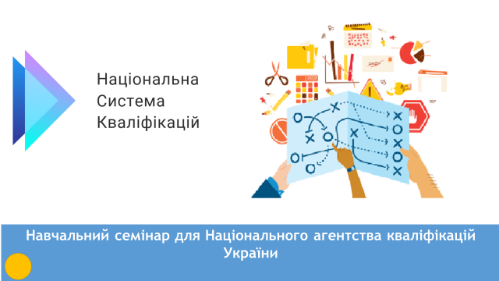 | Welcome to Torino  You will have many detailed presentations these days. That is why I decided to use a different format. My presentation is a Pecha Kucha of 20 slides lasting 20 second each = 6.40’’
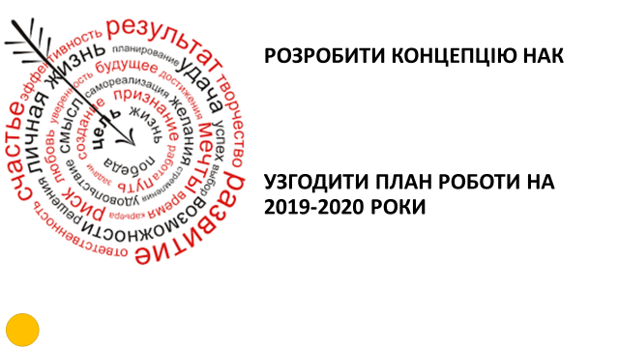 | The training has two main objectives  - Elaborating the concept of NAK  - Agree a work plan for 2019-2020  And of course understanding what NAK will do
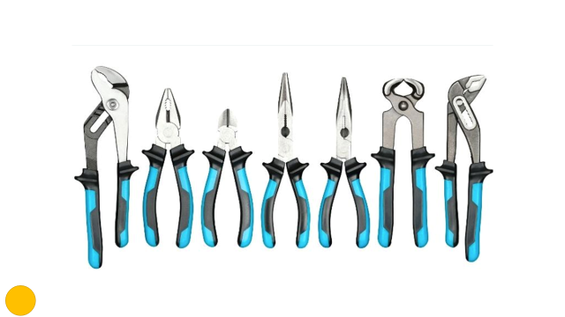 | According to the Law on Education NAK has 17 tasks. We will analyse and discuss together what they mean in practice for NAK and compare them with the tasks of other agencies
 | NAK has a board of 12 members and will have a large secretariat. The secretariat will be established and grow during 2019-2020. How NAK is organised and who will be involved in which tasks is defined in the concept.
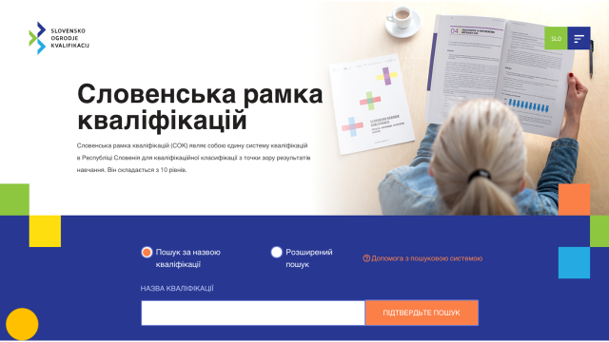 | NAK task will manage the register, including register includes relevant and quality assured standards, accredited qualification centres and possibly other things too. The register is a database for everyone that needs to be filled with entries as soon as possible.
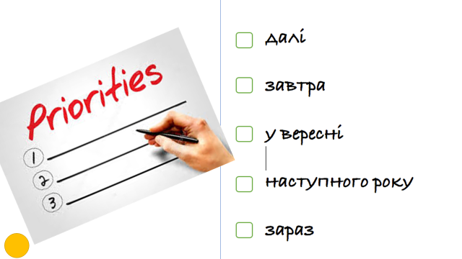 | You cannot do everything at once. The first rule of planning is one item first. We need to establish the sequence of the tasks, in order to get NAK on its feet and to show it can achieve results quickly.
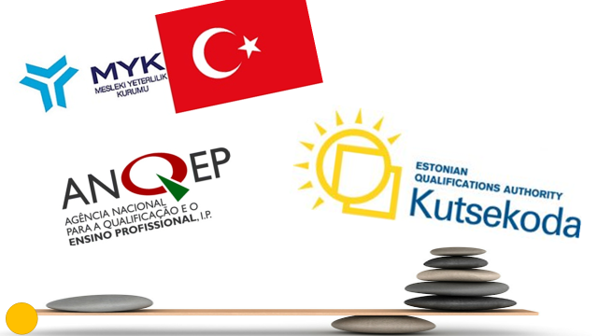 | NAK is unique in Ukraine, but fortunately, there are similar organisations abroad. We have invited similar agencies ANQEP from Portugal, VQA from Turkey, and Kutsekoda from Estonia to compare them with NAK and to share their experience.
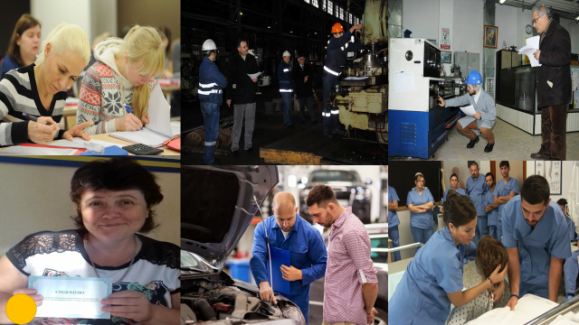 | These pictures are from existing qualification centres abroad and in Ukraine. NAK will introduce independent assessment, widen the validation of non-formal and informal learning and support the establishment of qualification centres.
We are living in a fast changing world.
What kind of qualifications will Ukraine need in five years’ time? NAK will work with other institutions and stakeholders to clarify this. We will look at the processes that could address this task.
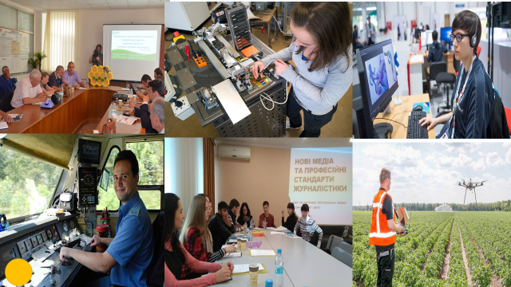 | Occupational standards describe the competences that people need to have to be effective in the workplace. There are changes in existing occupations and completely new occupations emerging. The Classifier of Occupations is sometimes a barrier to these innovations.
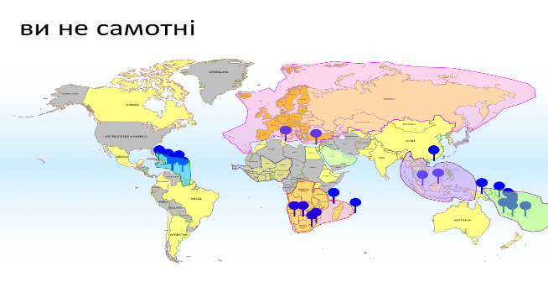 | Our research shows that 150 countries develop National Frameworks of Qualifications. Moreover, there are Qualifications Frameworks that cover several countries, including EQF, the QF of the European Higher Education Area and the ASEAN Qualifications Reference Framework.
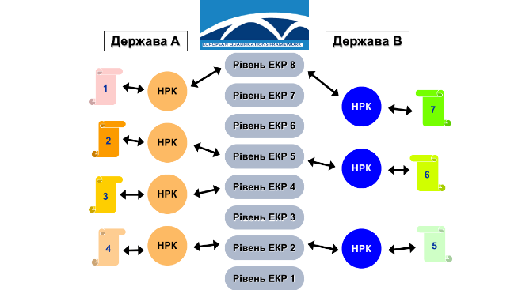 | The EQF covers 39 countries in and around the EU to allow comparison of their qualifications. The association agreement mentions the EQF and the new 2018 EQF Recommendation opens the door for alignment with Ukraine, but first we need qualifications in the NQF.
 | NAK is a collegial body that acts between stakeholders and institutions. This is a balancing act, that requires good coordination. Coordination is not telling others what to do, but bringing together different inputs and making sure, they lead to good results.
 | In order to use the opportunities of the NQF and help people to get access to qualifications, NAK will have to communicate with actors and final beneficiaries (learners, employers). This is more than just providing information. A website is already designed.
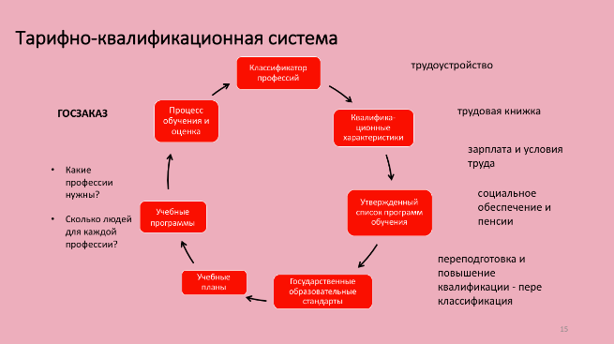 | The legacy of the Tariff Qualification System is strong, but many aspects are out of date. NAK will help to create a new Qualifications System for the 21st century. One urgent tasks is to stimulate the development of occupational standards replacing qualification characteristics.
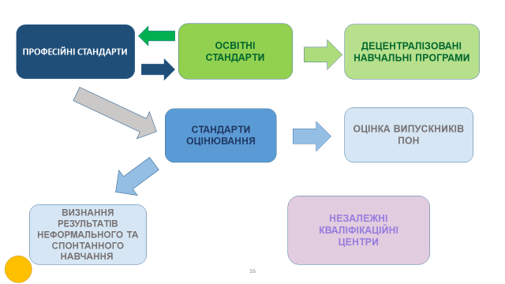 | Occupational standards are the starting point for defining educational standards that inform decentralised education programmes and for elaborating assessment standards for independent assessment of graduates and validation of non-formal and informal learning in Qualification Centres.
 | The value of qualifications in Ukraine is often not clear. Safeguarding the quality of qualifications is the main mission of NAK. Some people are sceptical about it. Others with high hopes. Quality and quality assurance should be guiding principles in what NAK does.
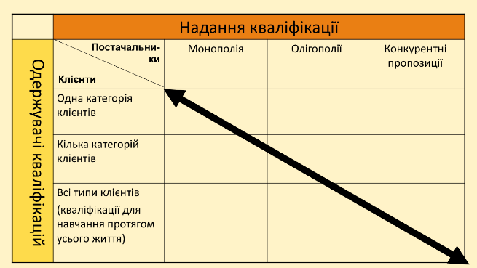 | With lifelong learning countries move from monopolies of issuing qualifications for specific categories of learners by the Ministries of Education, to a market where there are many organisations offering qualifications to people of all ages. NAK helps to regulate this market.
 | On 17/12/2018 the financing agreement on the EU4Skills project for the modernisation of vocational education was signed, that includes support for the capacity building for NAK. Our GIZ colleagues here want to understand how they can support NAK with the project.
 | Today you may think NAK will have a very difficult task and we will never manage. We hope that on Thursday you will have a better view of what is ahead and can return home with some self-confidence.

